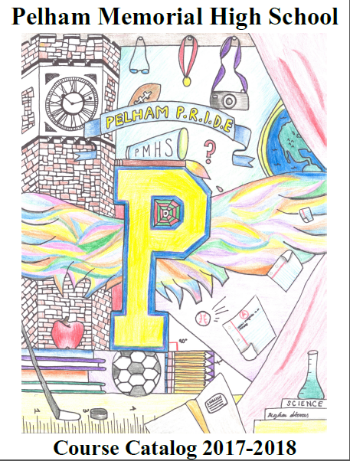
Course Catalog 2022-2023

Table of Contents

Principal's Message Page 1
Statement of Philosophy Page 2
Vision Statement Page 3
Choosing a Program Page 4
Special Notations Page 5
Graduation Requirements Page 6
Understanding the Transcript Pages 7-8
National Honor Society Page 9
NCAA Eligibility Page 10
NCAA Division I Sliding Scale Page 11
List of Approved NCAA Core Courses Page 12
Board of Cooperative Educational Services (BOCES) Page 13
Art Course Offerings Pages 14-18
English Course Offerings Pages 19-24
Mathematics Department Pages 25-31
Music Department Page 32-33
Physical Education Department Pages 34-35
Science Course Offerings Pages 36-41
Social Studies Course Offerings Pages 42-50
Technology Page 51
World Languages Pages 52-57

BOARD OF EDUCATION

Ms. Jessica DeDomenico, President
Ms. Sue Bratone Childs, Vice President

Mr. John Brice, Member
Mr. Vincent Mazzaro, Member
Dr. Michael Owen-Michaane, Member
Mr. Ian V. Rowe, Member
Ms. Leah Tahbaz, Member

ADMINISTRATION

Dr. Cheryl Champ Superintendent of Schools
Dr. Steven Garcia Assistant Superintendent for Curriculum, Instruction and Personnel
Mr. Mark Berkowitz Principal
Ms. Bethany Antonelli Assistant Principal
Mr. Eugene Farrell Director of Counseling Services
Ms. Julia Chung Assistant Superintendent of Pupil Personnel Services
Mr. James Hricay Assistant Superintendent for Business
Dr. Maria Thompson Director of Humanities
Mr. John Sebalos Director of Technology
Dr. Tom Callahan Director of Mathematics and Science
Mr. Christian Hodge Director of Athletics

Principal’s Message

Dear Students,

This course catalog has been designed to provide you with the information needed to plan your academic program for the 2022-2023 school year. Please review this catalog thoroughly with your parent/guardian before meeting with your counselor to request courses for next year. Counselors will be visiting your classes to explain the process for registering for next year’s courses. Then you will have an opportunity to meet with your counselor to discuss your program and to submit your course requests.

PMHS will continue to provide open access to honors and Advanced Placement courses for all students. This means that, while recommended criteria will remain as guidelines, and you will still be required to have taken prerequisite courses (where applicable), any student who seeks the additional challenge of an honors or AP class will have the opportunity to do so. Since these courses are rigorous, with increased expectations regarding the level of student work, conversations should take place between you, your family, current teacher, and school counselor to determine if placement in one or more of these courses is in your best interest. With that said, we encourage you to strive to consistently challenge yourself during your time at PMHS.
In the beginning of the catalog is a table that outlines the credits you will have to earn and the state exams you will have to pass in order to earn a diploma from Pelham Memorial High School. There is also information about NCAA eligibility requirements for students planning to participate on Division I and Division II sports teams. Eligibility for the National Honor Society is also included.

Sincerely,

Mark Berkowitz
Statement of Philosophy

Because young people have unique educational needs and capabilities, and they learn and grow in different ways, Pelham Memorial High School offers a variety of learning experiences. The school provides transitional programs between the more directed and structured environment of the middle school and the independent adult experiences beyond high school.

Pelham Memorial High School’s mission is to prepare students to meet the challenges of a rapidly changing and complex society. PMHS strives to engender respect for self and others in the school, in the community and in the world at large. To this end, the school offers a program designed to develop the cognitive skills and the knowledge, as well as the affective behaviors and attitudes that will lead students to social responsibility and a desire for lifelong, self-directed learning.

Pelham Memorial High School Mission Statement

Pelham Memorial High School is dedicated to the promotion and achievement of academic excellence.

We
…strive to create a secure and supportive environment which promotes the intellectual, emotional, and physical well-being of all members of the school community,
…celebrate diversity and encourage tolerance and respect for individual and cultural differences,
…uphold the tenets of a democratic society,
…provide our students with experiences that enable them to make ethical choices and function in our ever-changing and technological world,
…foster the development of critical thinking, problem solving, creativity and love of learning.
…encourage the recognition of learning as a life-long process.

Pelham Memorial High School will continue to cultivate these ideals and invites all members of the school community to share in this endeavor.

Vision Statement

The Pelham Memorial High School community is committed to fostering a safe and nurturing environment in which all students can achieve their greatest potential in every endeavor. We are dedicated to developing confident, well-rounded life-long learners ready to become productive individual contributors and the leaders of tomorrow.

Open Access Honors/Advanced Placement Courses

PMHS provides open access to all honors and Advanced Placement (AP) courses for all students. Any student who seeks the additional challenge of an honors or AP class will have the opportunity to do so. Students will, however, still be required to have taken prerequisite courses when applicable. Since honors and AP courses are rigorous, with increased expectations regarding the level of student work, conversations should take place between the student, parents, current teacher, and school counselor to determine if placement in one or more of these courses is in the best interest of the student. Teachers will be asked to recommend students who may require a level change and to discuss this recommendation with the student and their parent. Please note that open access does not apply to dual enrollment courses taken for college credit from SUNY, WCC, Adelphi or SUPA.

Choosing a Program

Each student has a right to equal access to all District activities provided they meet the established prerequisites. Membership and participation in the curricular and extracurricular activities will not be denied on the basis of race, sex, marital status, color, religion, national origin or disability.

The graduation requirements outlined represent the minimum number of courses needed to earn a Pelham Memorial Regents Diploma. When making choices, students should also keep in mind that future employers and colleges expect a rigorous program of study.

Students seeking employment following graduation should elect subjects related to their future career areas. For specific college entrance requirements, one should consult the school and college catalogs in the Counseling Office.

It should be clearly understood that the availability of courses listed in this publication is subject to recommendations of the administration and final action and authorization by the Board of Education, as the Board develops its budget for next year.

Course requests will be posted on the portal in April. At that time, unless a parent specifies in writing, those courses become a commitment for the 2022-2023 school year. Changes after that date will only be made at the discretion of the faculty.

All students who register for Advanced Placement and college level courses will receive a course description sheet which must be signed and returned by April 15. It is important for students to understand the course requirements and demands prior to enrollment.

Electives
Students may choose from the full range of course offerings at Pelham Memorial High School to fulfill elective requirements. The majority of students take courses in the required academic areas beyond the minimum and these count as electives. This is also true in the arts, music, and technology areas.

Students and parents should meet with counselors to plan course selections over the four-year high school period to insure that future educational and career goals will be met. Regular contact with a student’s counselor regarding course selection and planning for after high school opportunities is strongly advised.

Notations for all Classes
* All students must participate in Physical Education each year. They must earn the equivalent of two
Physical Education credits to graduate.

* Enrollment in courses is dependent upon budgetary constraints and number of student requests.

Grading System Formula

For full-year courses that have a midterm and a final exam, quarterly grades will be weighted as 4/19 of a student’s final course grade. Midterms will be weighted as 1/19 and final exams will be weighted as 2/19 of a student’s final course grade. For full-year courses that have a midterm, but do not have a final, quarterly grades will be weighted as 4/17 and the midterm will be weighted as 1/17. For full-year courses that do not have a midterm, but do have a final exam, quarterly grades will be weighted as 2/9 of a student’s final course grade. Final exams will be weighted as 1/9 of a student’s final course grade. For full-year courses that do not have a midterm or a final exam, quarterly grades will be weighted as ¼ of a student’s final course grade. For half-year courses with a final exam, quarterly grades will be weighted as 4/9 and the final exam will be weighted as 1/9 of a student’s final course grade. For half-year courses with no final exam, quarterly grades will be weighted as ½ of a student’s final course grade.

Student Advancement

Student Advancement from grade level to grade level will be determined by courses completed by the end of August. Thus, to move from 9th grade to 10th grade a student will have to have earned 5.50 credits; from 10th grade to 11th grade, 11.00 credits, and from 11th grade to 12th grade, 16.5 credits; for graduation, 22.5 credits. Students having difficulty meeting these requirements will be monitored by their counselor and the administration.

Special Notations
Inc. Incomplete – must be made up within ten (10) school days of the close of the marking period or the grade becomes an F unless an extension is approved by the Principal.

P or F Grade usually assigned to courses not counted as part of GPA

Grade + NC Grade but no credit because of excessive absence

NG No grade has been assigned

D/P or D/F Course dropped after the deadline while passing/failing

Class Rank
Pelham Memorial High School does not rank its students. However, they will receive a weighted Grade Point Average. Honors are weighted 1.05, Advanced Placement, and college level courses are weighted 1.10. All other courses are not weighted. A mathematical computation is done to determine the weighted GPA.

Weighted GPA’s are determined at the end of the junior year. These include all courses completed and eighth grade courses for which students receive high school credit. Grade Point Averages are computed after the fall semester of senior year.

Honor Rolls
Honor Roll: 85% unweighted average, with no grade below 75
High Honor Roll: 90% unweighted average, with no grade below 75

The academic honor rolls are published on our website after each of the four marking periods. All subjects are included in calculating honor rolls with the exception of support class, resource room and courses that are taken as pass/fail.

Courses Not Offered
For alternative programs not offered at PMHS, please see your School Counselor. Prior approval must be granted before enrolling in a course.

Dropping Courses/Changing Levels
Before any change is processed, dropping a course or having a change in level at any time requires written permission from:

1. The student
2. His or her parent/guardian
3. The subject area teacher
4. Director or Subject Coordinator
5. The school counselor

Once approved by the teacher, students are responsible for returning all course books and materials.

Students may drop a full year course, change levels, or drop a first semester course up to October 6th. Students may drop a second semester course by March 3rd. No permanent record of the dropped course will be kept on the final report card or transcript, if they are dropped by the aforementioned dates.

Students must attend each scheduled class until the course is officially dropped by the school counselor. Students may not stop attending class simply because of intentions or plans to drop the class. Nonattendance to classes that are not yet officially dropped constitutes class cutting and may result in disciplinary action.

Adding a Course
When adding a course, students must begin attending the class on the effective starting date as indicated on their new schedule. A course may be added up until the completion of the 2nd 6 day cycle.

In addition, students wishing to move up a level (i.e, Regents to honors/AP) must do so no later than the completion of the 2nd 6 day cycle and satisfy all criteria.

Full-Time Status
To be considered full-time, students are required to be enrolled in a minimum of 5.5 credits per semester.

GRADUATION REQUIREMENTS

REGENTS DIPLOMA
English 4
Social Studies 4
Math 3
Science 3
LOTE* 1
Art/Music/Technology 1
Writing Seminar**** .5
Health .5
Physical Education 2
Electives 3.5
TOTAL 22.5

Students must pass the following 4 required Regents Exams or Assessments:

1 Math, 1 Science, 1 Social Studies, ELA

And 1 of the following:

- Social Studies Regents
- Science Regents
- Math Regents
- Pathways Alternative (See Counselor)

* Students are required to have completed 2 units of foreign language study in middle school and pass the foreign language proficiency test or earn one unit of credit in a foreign language in high school.
** Students who acquire 5 credits in Career and Technical Education may be exempt from the LOTE (Languages Other Than English) requirement.
***40 required hours of Service Learning
****All students must complete writing seminar
Safety Net for Students with Disabilities:
Regents Score of 55-64
*See your designated school counselor regarding compensatory options and appeals for graduation.
Understanding the Transcript

A. Personal student information, including: name, student ID number, current grade-level, date of birth, gender, anticipated graduation date and diploma type.

B. Pelham Memorial High School’s address and contact information.
The college entrance examination code (CEEB code) is utilized by colleges and universities, the College Board, and ACT for identifying and linking our school with college entrance exam scores (e.g., PSAT, SAT, SAT Subject Test, AP, etc.).

C. Cumulative weighted and un-weighted grade point average. Advanced Placement, Syracuse University (SUPA), State University of New York (SUNY) are weighted at 1.10 and Honors courses are weighted at 1.05. All other courses are un-weighted. Total credits are also noted.

D. Course titles by grade. All high-school courses taken by students are included on the transcript, including those taken during 8th grade (e.g., Foreign Language, Algebra, Studio in Art, Earth Science).

E. Yearly Un-weighted Grade Point Average is calculated by totaling the final grades (multiply semester courses by .5) and dividing by total credits earned.

F. New York State Exams: All high school Regents exams are recorded, including the Second Language Proficiency exam from 8th grade. These exams are only recorded as best effort. Students can retake exam, and only the highest score earned will be reported on the transcript.

G. Grade code conversion chart reflects equivalent numerical grades as alpha marks. Several high schools, colleges and universities request this conversion.

H. Signature - the transcript must be signed and have an official seal in order to be accepted as an official transcript.

I. This section reflects the student’s current courses for the present school year.

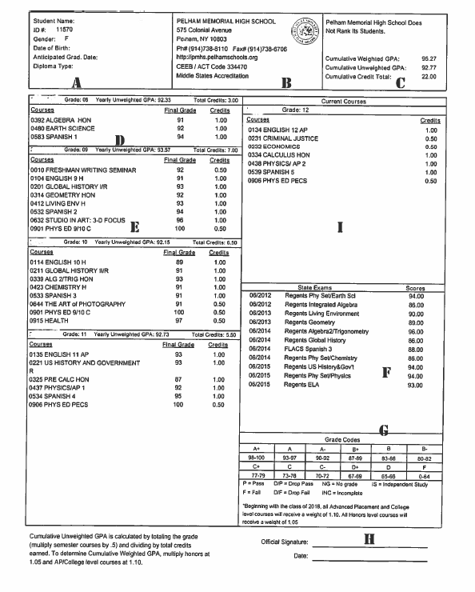
NATIONAL HONOR SOCIETY
The National Honor Society was founded in 1921 by the National Association of Secondary Schools Principals. According to this organization, a student must demonstrate outstanding performance in the four criteria of scholarship, leadership, character and service. Based on the scholarship criteria students will be invited to a meeting in October where they will receive an application. After completed applications are submitted for consideration, a faculty committee evaluates the information. Letters of acceptance will be sent home.

Scholarship
Juniors and seniors with an un-weighted average of 89 and a weighted average of 90 will be eligible for consideration.
Leadership
The student who exercises leadership
- Exercises positive influence on peers in upholding school ideals
- Contributes ideas that improve the life of the school
- Exemplifies positive attitudes
- Inspires positive behavior
- Demonstrates reliability and dependability
- Is a leader in the classroom, at work, and in other school or community activities

Character
A person of character demonstrates the following qualities: respect, responsibility, trustworthiness, caring and citizenship. Additionally, a student of character:
- Takes criticism willingly and accepts recommendations graciously
- Cooperates by complying with school regulations
- Demonstrates high standards of honesty and reliability
- Shows concern, courtesy and respect for others
- Avoids cheating in written work and shows an unwillingness to profit by the mistakes of others
- Actively works to improve school environment
Service
The minimum needed to apply is 10 hours. Once inducted, 40 hours must be completed by the end of the academic year. Service hours in school or the community; must be activities for which the student did not receive academic credit or monetary compensation.
NCAA ELIGIBILITY

Many students in our athletic programs have achieved a high degree of competency in varsity sports to enable them to be considered for athletic scholarships. It is important for students and parents/guardians to understand that Division I NCAA eligibility for athletes is based on a sliding scale that consists of SAT or ACT scores and grade point average (GPA). Division II has no sliding scale. The minimum core grade point average is 2.30. The minimum SAT score is 820 (V & M) and the minimum ACT score is 68. 14 core courses are required for Division II. 16 core courses are required for Division I. The SAT combined score is based on the verbal and math sections only. The writing section will not be used. SAT and ACT scores must be reported directly to the clearinghouse from the testing agency. For more information regarding the rules, please go to WWW.NCAA.ORG click on “Academics and Athletes” then “Eligibility and Recruiting”.

Core Units Required for NCAA Certification
Academic Requirements | Division I | Division II
English Core Courses | 4 Years | 3 Years
Math Core Courses (Including 1 year of algebra and 1 year of higher level  math such as geometry or a course for which geometry is a prerequisite) | 3 Years | 2 Years
Science Core Courses (Including 1 year of lab sci.) | 2 Years | 2 Years
Social Science Core Courses | 2 Years | 2 Years
From English, Math, or Science | 1 Year | 3 Years
Additional Core Courses (English, Math, Science, Social Science, Foreign  Language, Philosophy, or Nondocrinal Religion) | 4 Years | 4 Years
Total Core Units Required | 16 | 16

When a student registers for the SAT or ACT, he or she can use the NCAA Eligibility Center code of 9999 so his or her scores are sent directly to the NCAA Eligibility Center from the testing agency. Test scores on transcripts will NOT be used in his or her academic certification. A combined SAT score is calculated by adding reading and math sub-scores. An ACT sum score is calculated by adding English, math, reading and science sub-scores. A student may take the SAT or ACT an unlimited number of times before he or she enrolls full time in college. If a student takes either test more than once, the best sub-score from different tests are used to meet initial-eligibility requirements. If a student took the SAT before March 2016 and then took the redesigned SAT at a later date, the NCAA Eligibility Center will not combine section scores from the old and redesigned SAT when determining his or her initial eligibility. The NCAA Eligibility Center will only combine section scores from the same version of the test. Because the redesigned SAT varies in design and measures different academic concepts than the old SAT, a numerical score on the old test may not be equivalent to the same numerical score on the redesigned test.

NCAA Division I Sliding Scale Core GPA/Test-Score

NCAA DIVISION I SLIDING SCALE
Core GPA | SAT  Reading and Math  Only | ACT Sum | Core GPA |  | SAT  Reading and Math  Only |  | ACT Sum
3.550 | 400 | 37 | 2.750 |  | 720 |  | 59
3.525 | 410 | 38 | 2.725 |  | 730 |  | 60
3.500 | 420 | 39 | 2.700 |  | 740 |  | 61
3.475 | 430 | 40 | 2.675 |  | 750 |  | 61
3.450 | 440 | 41 | 2.650 |  | 760 |  | 62
3.425 | 450 | 41 | 2.625 |  | 770 |  | 63
3.400 | 460 | 42 | 2.600 |  | 780 |  | 64
3.375 | 470 | 42 | 2.575 |  | 790 |  | 65
3.350 | 480 | 43 | 2.550 |  | 800 |  | 66
3.325 | 490 | 44 | 2.525 |  | 810 |  | 67
3.300 | 500 | 44 | 2.500 |  | 820 |  | 68
3.275 | 510 | 45 | 2.475 |  | 830 |  | 69
3.250 | 520 | 46 | 2.450 |  | 840 |  | 70
3.225 | 530 | 46 | 2.425 |  | 850 |  | 70
3.200 | 540 | 47 | 2.400 |  | 860 |  | 71
3.175 | 550 | 47 | 2.375 |  | 870 |  | 72
3.150 | 560 | 48 | 2.350 |  | 880 |  | 73
3.125 | 570 | 49 | 2.325 |  | 890 |  | 74
3.100 | 580 | 49 | 2.300 |  | 900 |  | 75
3.075 | 590 | 50 | 2.299 |  | 910 |  | 76 | A
3.050 | 600 | 50 | 2.275 |  | 910 |  | 76 | C
3.025 | 610 | 51 | 2.250 |  | 920 |  | 77 | A
3.000 | 620 | 52 | 2.225 |  | 930 |  | 78 | D
2.975 | 630 | 52 | 2.200 |  | 940 |  | 79 | E
2.950 | 640 | 53 | 2.175 |  | 950 |  | 80 | M
2.925 | 650 | 53 | 2.150 |  | 960 |  | 81 | I
2.900 | 660 | 54 | 2.125 |  | 970 |  | 82 | C
2.875 | 670 | 55 | 2.100 |  | 980 |  | 83
2.850 | 680 | 56 | 2.075 |  | 990 |  | 84 | R
2.825 | 690 | 56 | 2.050 |  | 1000 |  | 85 | E
2.800 | 700 | 57 | 2.025 |  | 1010 |  | 86 | D
2.775 | 710 | 58 | 2.000 |  | 1020 |  | 86 | S
 |  |  |  |  |  |  |  | H
 |  |  |  |  |  |  |  | I
 |  |  |  |  |  |  |  | R
 |  |  |  |  |  |  |  | T
List of Approved NCAA Core Courses

The NCAA has approved the following courses for use in establishing the initial eligibility certification for student athletes enrolled in Pelham Memorial High School. If a course name does not appear on this list, it will not be tabulated in the core course credit total. Also, please note that not all courses are granted full credit. (For example, Algebra 1A is granted only .50 credits per year). Please check this list carefully. Not all PMHS courses are approved.

English Courses:
A Study of Dramatic Literature
Adelphi A Study of Dramatic Literature
English 9R Physics H
English 9H Physics I AP
English 10R Physics II AP
English 10H Forensics Science
English 11R
English 12R Mathematics Courses:
Creative Writing Algebra
AP English Literature Algebra 1A (.50 credit/year)
AP English Language Algebra 1B (.50 credit/year)
Comparative Fiction Data Science
SUPA Practices of Academic Writing Discrete Mathematics
SUPA Presentation Speaking Geometry
Characters & Conundrums Geometry & Trigonometry
Geometry H
Algebra 2/Trigonometry R
Algebra 2/Trigonometry H
Pre-Calculus
Social Science Courses: Pre-Calculus H
Global History 1R Calculus H
Global History 1H Calculus AB/AP
Global 2R Calculus BC/AP
AP World History Statistics AP
US History & Government R
American History 11/AP
AP Government & Politics
European History AP
Criminal Justice
Sociology
Economics
Contemporary Economics
The Economics of Business
Psychology
SUNY Criminal Justice World Language Courses:
SUPA/AP Psychology
Military History French 1, 2, 3, 4/5, SUPA French
Public Policy and Politics Italian 1, 2, 3, 4/5, SUPA Italian
Human Rights Latin 4/5
Humanities Research Spanish 1, 2, 3, 4, 4/H, 5, AP, SUPA Spanish
Mandarin 1 ,2, 3, 4/5
Science Courses:
Earth Science R
Earth Science H
Living Environment R
Living Environment H
Topics in Physics/Chemistry/Biology
Chemistry R
Chemistry H
Chemistry AP This list reflects courses approved as
Biology AP of January, 2020. For an updated list,
Environmental Science AP please visit the ncaa.org website and check
Physics the “48H” list for Pelham High School
Intro to Science Research CEEB #334470
Science Instruction & Problem Solving SUNY
Principals of Engineering

Courses NOT approved – Career and College Ready, Consumer Math, Intermediate Algebra, Economics: Personal Finance

BOARD OF COOPERATIVE EDUCATIONAL SERVICES (BOCES)

Secondary Day Career and Technical (CTE) Programs

The Career and Technical Education Programs prepare secondary student graduates with the career skills they need to find employment and/or pursue post-secondary education. Students spend half the day in their local high schools and the other half at the Career Services campus in Valhalla. Instruction is provided by certified teachers who have extensive professional experience in their respective fields. Each student masters job skills in a career cluster area during his or her stay (one or two years) at the campus. All programs carry up to four sequence credits per year toward graduation. The students may receive a technical endorsement on their Regents diploma provided they pass a national or state certification exam in their skill area. Articulation agreements are in place with colleges throughout New York State and other states that enable students to gain from 3 to 14 college credits while enrolled in Career courses.

BOCES Electives (4 Credits) Prerequisite: None

The following is a list of course offerings:
Animal Science
Architecture & Interior Design
Automotive Technology
CISCO
Collision Technology
Commercial Art/Multimedia
Computer Information Systems & Medical Administrative Assistant
Construction/Plumbing
Cosmetology
Culinary Arts
Electrical Construction
Emergency Medical Services
Fashion Design/Merchandising
Nursing Assistant
Pre Engineering/CAD
Security, Law & Policing
Sound Production
TV/Video Production

Note: College credits are available depending upon the course taken.
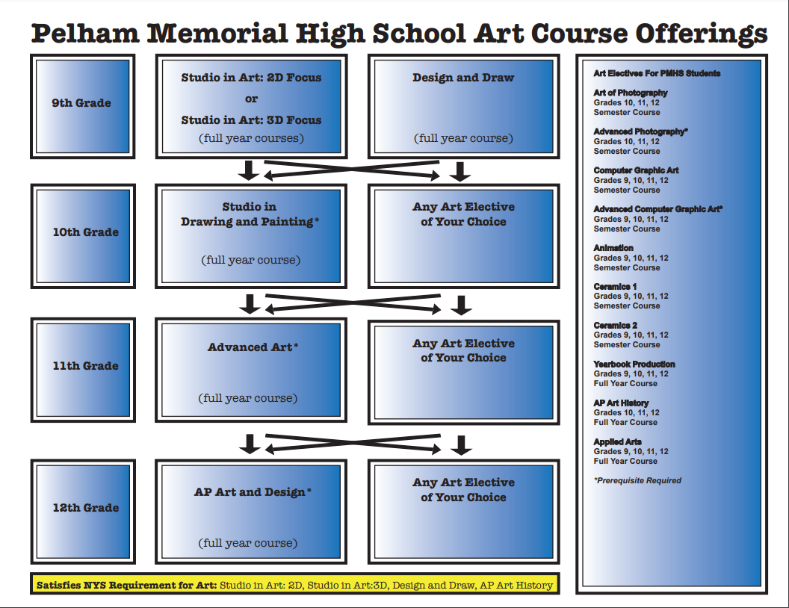

ART DEPARTMENT

The creation of and participation in the arts is an integral part of the human experience. The Art Department strongly believes that every student has the potential to develop their artistic abilities and create meaningful works of art. Participation in the arts is fundamental to a well rounded education. The Art experience provides students with the opportunity to develop self awareness, personal creative growth and an appreciation for the arts within our community.

Courses in the Art department include a variety of disciplines, including fine arts, computer graphics, photography, art history and many other exciting art opportunities that will give PMHS students a rich and diverse artistic experience with which to build their portfolios.

The Art Department is a place for all students, from those who take Art classes because they are enjoyable educational experiences to students whose passion for Art may lead to a college major or Art career. Students who may be interested in pursuing a college study or career in Art after high school should consult with their Art teacher as early as possible for advice on planning a sequential art program. Students who need to create a portfolio for admission to a college Art program should meet with their Art teacher in their junior year for guidance.
Courses that fulfill the New York State 1 credit arts graduation requirement for high school students:
DESIGN AND DRAW
1 Credit
Design and Draw is a foundation course that introduces the high school student to graphic design and provides opportunities for creative thinking, design decision-making, and self-expression. Students will use computer graphics to learn about the elements and principles of art and design. Projects will also incorporate learning from other subjects, such as Art History, Math, and Social Studies. Each project will be printed in color and will become part of each student’s portfolio. This course satisfies the NYS Art requirement necessary for graduation.

STUDIO IN ART: 2-D FOCUS
1 Credit

Studio in Art: 2-D Focus is a foundation course that is a prerequisite for all advanced fine art electives. It is designed to introduce the visual fine arts to the high school student. Students will learn the purpose of a studio, various art techniques and background art history. The class will have a 2-D focus (drawing, painting, printmaking, collage and other 2-D art-making techniques), but students will also get a taste of 3-D media. From the experience of working with various materials, students can make a decision about which courses to pursue next in their high school study of Art. This course satisfies the NYS Art requirement necessary for graduation.

STUDIO IN ART: 3-D FOCUS
1 Credit
Studio in Art: 3-D Focus is a foundation course that is a prerequisite for all advanced fine art electives. It is designed to introduce the visual fine arts to the high school student. Students will learn the purpose of a studio, various art techniques and background art history. The class will have a 3-D focus (ceramics, sculpture, etc.), but students will also get a taste of 2-D media. From the experience of working with various materials, students can make a decision about which courses to pursue next in their high school study of Art. This course satisfies the NYS Art requirement necessary for graduation.

ADVANCED PLACEMENT ART HISTORY Prerequisite: None
1 Credit Grades 10, 11, 12
Advanced Placement Art History is a college level course that explores such topics as the nature of art, its uses, its meanings, art making, and responses to art. Through investigation of diverse artistic traditions of cultures from prehistory to the present, the course fosters an in-depth and holistic understanding of the history of art from a global perspective. Students learn to apply skills of visual, contextual, and comparative analysis to engage with a variety of art forms, including 2-dimensional media, 3-dimensional media, and architecture. Students will construct understanding of individual works and interconnections of art-making processes and products throughout history.
No prior exposure to art or art history is required. Students who have been successful in humanities courses, such as history and literature, or in studio art courses are especially encouraged to enroll since those experiences will likely support and enrich the context of the art history course. All students will take the College Board Advanced Placement Art History exam in May. This course satisfies the NYS Art requirement necessary for graduation.

Art Electives:

STUDIO IN DRAWING AND PAINTING Prerequisite: Studio in Art or
1 Credit Design & Drawing for Production
Studio in Drawing and Painting is an advanced-level elective Art class and is recommended for a portfolio track. Students will use the knowledge and techniques they learned in Studio in Art and/or Design and Drawing for Production and further develop their individual style and creativity in drawing and painting. Through a wide variety of subjects, media and background art history, students will learn more about the advanced practices, techniques and procedures in creating and producing 2-D art. The student’s goal is to begin to develop a more sophisticated portfolio that represents his/her personal style. Please know the demands and expectations for an advanced class are more challenging than an entry level art class.

ADVANCED ART/ADVANCED PLACEMENT ART AND DESIGN (APAD) Prerequisite: Studio in Art and
1 Credit Studio in Drawing and Painting

This class may be taken as a 1 or 2 year plan of study. Advanced Placement Art and Design/Advanced Art enables the highly motivated student to perform at college level and receive college credit while still in high school. The APAD program is a portfolio based exam rather than a written exam. APAD is designed for students who are seriously interested in producing a wide variety of 2-D art. AP portfolio work can include any combination of traditional drawings, paintings, collages, mixed media, digital images and/or photography. In addition to regular class time, students will need to work extra or independently to complete their portfolio requirements. Class trips to galleries and/or museums will be planned during the school year to broaden the student’s creation and connection to the arts. Assessment for the AP program is portfolio based using criteria from the AP College Board for Both Advanced Art and APAD. Students use a national standard for analyzing, evaluating and assessing their art work. Please know the demands and expectations for students are more challenging than a typical high school art class. Portfolio work must reflect first year college-level standards. All students must complete requirements for the AP Art and Design Portfolio.

STUDIO IN CERAMICS 1 Prerequisite: None
1/2 Credit

Studio in Ceramics is an elective class designed for students who are interested and enjoy working with clay. Students will experiment with a variety of hand building techniques (pinching, coiling and slab building) while creating a wide variety of theme related vessels, reliefs and free-standing sculpture. Students will learn the properties of handling and recycling clay as well as glazing and firing techniques. The course will cover as many approaches to the use of clay as possible, always allowing time for the student to explore methods of the greatest interest and value to him/her.

STUDIO IN CERAMICS 2 Prerequisite: Ceramics 1
1/2 Credit

Students will continue to develop skills in hand building: pinch, coil, and slab construction. Students will learn to create larger pieces while developing refinement of form, and will learn additional glazing techniques.

APPLIED ARTS Prerequisite: None
1 Credit

Applied Arts is a CRAFT BASED Art Elective intended for students who are interested in the creative process. Students will explore a variety of materials, develop their own unique art style and gain an appreciation of both craft and design as they explore a variety of hands-on techniques in this dynamic and rewarding art class.

THE ART OF PHOTOGRAPHY Prerequisite: None
1/2 Credit Grades 10-12

This introductory course is designed to encourage students to use the camera creatively and to consider photography as a communication tool. Emphasis is placed on both technical and aesthetic concerns. In this course students will learn to operate a 35mm Digital SLR camera. They are introduced to the creative controls of the camera such as, aperture, shutter speed, and ISO to create compelling images. Aside from technical aspects of photography, students will study the work of famous photographers to better understand the historical impact of the medium, as well as gain insight into their own work. Students will learn to process their images in a digital format. Students work toward the completion of a portfolio of ten matted prints, due at the end of the semester. Students are highly recommended to use their own Digital SLR camera, however, if they do not have one, one may be provided to them based on availability.
ADVANCED DIGITAL PHOTOGRAPHY Prerequisite: The Art of Photography
1/2 Credit Grades 10-12

Advanced Digital Photography follows “The Art of Photography” course. Students work to obtain mastery of the creative controls of the camera. They continue to hone their skills in composition, lighting, photo-editing, and processing their work in a digital format. Students work toward the completion of a portfolio of ten matted prints, due at the end of the semester. Students are highly recommended to use their own Digital SLR camera, however, if they do not have one, one may be provided to them based on availability.
YEARBOOK PRODUCTION AND PRINT Prerequisite: None
1 Credit
The Pelican Yearbook has received national recognition in creative concept, layout and design, photography and overall yearbook production from CSPA (Columbia Scholastic Press Association) and NSPA (National Scholastic Press Association). This course teaches students 21st century real world life skills in desktop publishing. Students work closely together as a yearbook team and perform all the skills and processes necessary to publish the Pelican
Yearbook, the largest single publication created by students in our school district. Students will learn and demonstrate the skills involved in the publishing industry which includes layout design, interviewing, writing and editing skills, technology skills, digital photography skills, business management and team building. In addition, students will attend Yearbook workshops at Pace University, Columbia University and an optional summer program at Gettysburg College.

COMPUTER GRAPHIC ART Prerequisite: None
1/2 Credit
This course will introduce students to Adobe Illustrator, a design-industry standard. Students will learn concepts, features and tools while they begin to understand graphic design. They will learn to create precise drawings and graphics and will understand the tools and commands in Adobe Illustrator. Each project will be printed in color and will become part of the student’s portfolio.
ADVANCED COMPUTER GRAPHIC ART Prerequisite: Computer Graphic Art
1/2 Credit
This course follows the Computer Graphic Art course. Students will continue using Adobe Illustrator, a design-industry standard. Students will continue learning to create precise drawings and graphics and will add to their understanding of the tools and commands in Adobe Illustrator. Emphasis will be placed on aesthetics and advanced design techniques. Each project will be printed in color and will become part of the student’s portfolio.
3D DRAWING Prerequisite: None
1/2 Credit
Students will learn the important fundamental concepts, features and tools while they begin to master drawing, seeing and thinking in 3D. Students will work on lettering and drawing in 3D as well as perspective drawing. These projects reinforce basic design and drawing concepts. Each project will be printed in color and will become part of the student’s portfolio.
ANIMATION Prerequisite: None
1/2 Credit
Students will learn to use Adobe PhotoShop to design and create animation shorts. Assignments will focus on using tools and commands in Adobe PhotoShop to move objects across the animation frame. Each project will become part of the student’s portfolio.

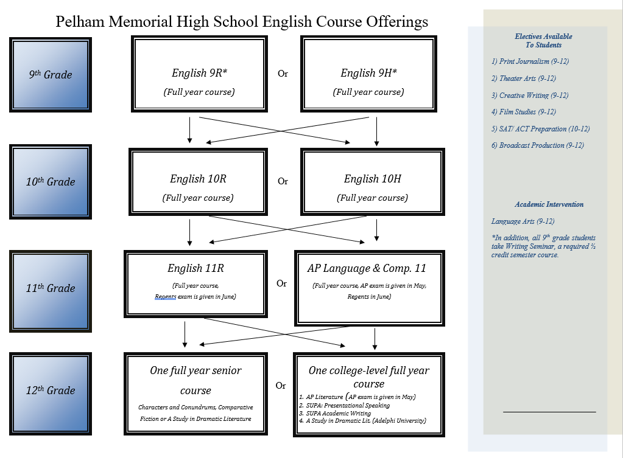

ENGLISH DEPARTMENT

The English program is designed to improve a student’s awareness of the essential role that the English language and its literature plays in one’s personal and career development. The program emphasizes the development of powers of comprehension, critical thinking skills, and fluency in written expression and oral communication of ideas and emotions. Courses are aligned with the Common Core New York State Standards to ensure proficiency in reading, writing, listening, and speaking.

The department provides for differences in ability and achievement with a two-level system in grades 9 through 11: Regents and Honors in grades 9 and 10, and Regents and Advanced Placement English Language and Composition in grade 11. During senior year, students can choose either Advanced Placement Literature and Composition, SUPA Presentational Speaking, SUPA Practices of Academic Writing, Adelphi University A Study in Dramatic Literature, or one of our yearlong senior elective course offerings.

At each grade level, students read a variety of literature, including short stories, novels, plays, poetry, and non- fiction. The major differences between levels include materials used, the approach to those materials, and the rate of progress.

ENGLISH REGENTS 9, 10, 11
Grades 9, 10, 11
1 Credit each course (full-year courses)

English Regents course in grades 9, 10 and 11 provide students with the literary content and writing and speaking skills that will prepare them for post-high school education. Using a combination of modern and traditional literature, these courses emphasize the ideas and attributes traditionally associated with a humanities education. In June of junior year all students will take the state-mandated Regents Examination in English Language Arts (Common Core).

ENGLISH HONORS 9 and 10
Grades 9 or 10
1 Credit each course (full-year courses)

The English Honors courses in grades 9 and 10 provide a broad experience in modern and traditional literature and in-depth literary study of the works read. Required reading is lengthy and of a demanding nature. The composition program requires outstanding technical ability as well as insight and imagination in written interpretation.

ADVANCED PLACEMENT ENGLISH LANGUAGE AND COMPOSITION 11
Grade 11
1 Credit (full-year course)

This course is designed for highly motivated juniors of superior ability who love reading and writing in a variety of forms. It is the equivalent of a freshman college course in composition. Students will learn to understand complex texts and write with sophistication, maturity, and an awareness of audience and purpose. They will carefully read primary and secondary sources and synthesize that material into their own pieces. Students will study American literature – both fiction and non-fiction, poetry and prose – to understand the rhetorical and linguistic choices authors make and apply these in their own compositions. Students take the state mandated Regents Examination in English Language Arts (Common Core) in June. All students must also take the College Board Advanced Placement Examination in English Language and Composition in May. A special reading assignment is given for the summer prior to the course. This course will prepare students for portions of the SAT Subject Test exam in Literature.
Link to College Board for AP Language: https://apstudent.collegeboard.org/apcourse/ap-english-language-and- composition

WRITING SEMINAR
½ Credit (semester course)

Writing Seminar is designed to guide students into developing as self-directed learners. Students learn to manage, monitor and modify their own learning through a focused study of the writing process. Through practice in the use of effective strategies, students broaden their ability to think about and demonstrate their understanding of what they learn in all subject areas. Successful completion of Writing Seminar is a requirement for graduation.

SENIOR YEAR ENGLISH

During their senior year, Pelham students may take either Advanced Placement Literature and Composition, SUPA Presentational Speaking, SUPA Practices of Academic Writing, Adelphi University A Study in Dramatic Literature, or one of our senior elective course offerings. As in college, seniors are encouraged to sign up for courses which match their interests. All seniors will complete a senior project in their senior English class.

Full-year Course Offerings for Seniors (Grade 12 only):

ENGLISH 12: COMPARATIVE FICTION
1 Credit (full-year course)

This full-year senior English course will bring film education into the English classroom by integrating reading, writing, and visual literacies. Through a series of participatory experiences, students will build an understanding of the connections between viewing a film and reading a text, as well as using specific strategies for active viewing and active reading. Activities will integrate reading, writing, and the viewing of short films. Students will study film and literature while drawing connections to similar themes and ideas represented in each. The literary focus for the class will be a mix of nonfiction and fiction genres as well as current events (i.e. NY Times.com and other media outlets). In this course, students also will hone the necessary research, writing, and presentation skills that will be required for life outside of PMHS. Students will plan, design and deliver multimedia presentations, give speeches, and write research papers on current topics presenting challenges to today’s society. This course will fulfill the English 12 state requirement. Students will complete a senior project during this course.

ENGLISH 12: A STUDY IN MODERN DRAMATIC LITERATURE
1 Credit (full-year course)

This full-year senior English course will focus on modern literature that is written for performance. This class will investigate elements of dramatic literature and the various forms of drama that have evolved from modern realism to comedy of manners to theater of the absurd, to farce. Students will focus on the exploration of drama, non-fiction, humor, gender and identity through various forms of modern theater. This course teaches students how to analyze and discuss contemporary plays and how to communicate their analyses in writing. The course encourages students to express their perspectives through in-class discussions and through writing. This course will fulfill the English 12 state requirement. Students will complete a senior project in this course.

ENGLISH 12: CHARACTERS & CONUNDRUMS - DILEMMAS IN LITERATURE, FILM, AND MEDIA
1 Credit (full-year course)

Whether you are watching the media, reading literature, or enjoying a film, ethical dilemmas are everywhere. Dilemmas will emerge like “Did the main protagonist have the right to do what he did to help his dying friend?” “What if it’s wrong, but I win?” In this full-year English 12 course, students will take a journey through the dilemmas faced by individuals and society both in fiction and out. The work of the course will involve analyzing varied texts, film, and media. Students will hone their critical reading and viewing skills as they discern their own opinions. This course will take an interdisciplinary approach, using diverse texts, in which students encounter elements of philosophy, psychology, and sociology to deepen understanding in academic writing and class discussion. This course will fulfill the English 12 state requirement, and students will complete a senior project and several writing assessments. The literary focus of the class will be a mix of nonfiction and fiction genres.

ADVANCED PLACEMENT (AP) ENGLISH LITERATURE AND COMPOSITION 12
1 Credit (full-year college-level course)

This course is designed for highly motivated seniors of superior ability who love literature. The course is the equivalent of a freshman college course in English composition and literature. Its specific objectives are to develop an emotional as well as intellectual response to many kinds of literature; to learn the basic techniques which the best writers have used to communicate their ideas and emotions; and to develop skills in literary interpretation, writing, speaking, and collaborative learning. Emphasis is on close reading of texts rather than on surveying a body of literature. All students must take the College Board Advanced Placement Examination in English Literature and Composition in May. College-level papers are required throughout the course. A special reading assignment is given for the summer prior to the course. Students will also complete a senior project. Link to College Board for AP Literature: https://apstudent.collegeboard.org/apcourse/ap-english-literature-andcomposition

A STUDY IN DRAMATIC LITERATURE (ADELPHI UNIVERSITY) ENGLISH (0122) 301
1 Credit (full-year college-level course)

This college-level dual enrollment course focuses on playwrights of the modern period, such as Ibsen, Shaw, Brecht, Chekhov, and O’Neill, with some study of contemporary playwrights whose works reveal the influence of their modern predecessors. This is an advanced English course (which can earn students 3 college credits through Adelphi University) for 12th-grade students that focuses on modern literature that is written for performance. This class will investigate elements of dramatic literature and the various forms of drama that have evolved from modern realism to comedy of manners to theater of the absurd, to farce. Students will focus on the exploration of drama, humor, gender and identity through various forms of modern theater. Additionally, dramatic literature will be studied comparatively within the fields of non-fiction, theater history, theater production, and cinema. This course will fulfill the English 12 requirement. Students may earn 3 college credits through Adelphi University by taking this course as a 12th-grade English class. While there is no formal entrance criteria, students are advised that this is a college-level class with appropriately rigorous expectations. The approximate cost for the class is approximately $390.00. Students will complete a senior project during this course.

SUPA: WRT 105: PRACTICES OF ACADEMIC WRITING
1 Credit (full-year college-level course)

This SUPA (Syracuse University Project Advance) course will foster a community of writers who have the specific purpose of developing as critical readers, writers, and thinkers. Students explore strategies of critical academic writing in various genres, including analysis, argument, and researched writing. Students learn to develop ideas through the choices they make as writers—from invention to making and supporting claims to sentence-level editing to designing finished print and digital texts. This college-level course challenges students to understand that effective communication requires people to be aware of the complex factors that shape every rhetorical context. Through this course, students will discover how their work as writers extends beyond the immediate requirements of the classroom and prepares them for effective engagement with issues in the workplace, local community, and global society. Students will engage in research, utilize and evaluate various resources and synthesize and apply research in accordance with citation, genre conventions and ethical standards Students will practice a range of revision strategies appropriate to various writing situations. This course will include fiction and non-fiction readings and will fulfill the full-year English 12 requirement. Students who successfully complete the course are entitled to a Syracuse University transcript recording 3 credits earned. Students are advised that this is a college level class with appropriately rigorous expectations including college-level papers and summer reading. The approximate cost for this class is approximately $345.00. Students will also complete a senior project in this course.

SUPA: CRS 325: PRESENTATIONAL SPEAKING
1 Credit (full-year college-level course)

Oral communication skills are essential to success in school, in business, and in life. This SUPA (Syracuse University Project Advance) course will improve your public speaking skills so that you are better prepared for college and your future career. CRS 325 presents the conceptual and practical dimensions of formal presentations in organizational settings. It is designed to build a solid understanding of the fundamentals of public presentations, as well as the ability to employ those skills flexibly so that a speaker can adjust selected topics and tactics to specific audiences. This course will include fiction and non-fiction readings and fulfills the full-year English 12 requirement. Students who successfully complete the course are entitled to a Syracuse University transcript recording 3 credits earned. While there is no formal entrance criteria, students are advised that this is a college level class with appropriately rigorous expectations. The approximate cost for the class is approximately $345.00. Students will also complete a senior project in this course.

ENGLISH ELECTIVES

In addition to grade level courses, students may choose to enhance their program of study with one of these electives. Electives do not fulfill the school requirement as English credit at any grade level. However, Print Journalism, Theatre Arts, Creative Writing, Film Study and SAT/ACT Preparation may be used as a fifth course in a five-credit sequence.

PRINT JOURNALISM
Grades 9-12
1 Credit (full-year course)

This course is designed for students who enjoy writing non-fiction and are interested in print journalism. Students will write original journalistic pieces to be published in the school newspaper, The Pel Mel. Print Journalism students are responsible for producing the newspaper as a part of their class. The course focuses on the different types of journalistic writing, revision, and layout design. Each student will have the opportunity to write for the following sections in the paper: news, editorials, features, and sports. Since this is an individualized project-based course, it is appropriate for students new to journalism and for those who have more experience producing a newspaper. On multiple occasions throughout the year, Print Journalism students will work in conjunction with the Broadcast Production class on collaborative projects. Students also have the option of taking the course for a full year for one credit.

THEATRE ARTS
Grades 9-12
1 Credit (full-year course)

This course provides students opportunities to develop an appreciation and respect for the craft of acting and production as a means of creative expression and for the collaborative effort of all involved in producing works of theater. Attention is also given to improvement of interpersonal skills and effective communication through collaborative work and dramatic activities including improvisation, movement, script analysis and scene work.
CREATIVE WRITING
Grades 9-12
½ Credit (semester course)

In this workshop, students explore the power of words. By experimenting with poetry, short stories, plays, and other genres, students discover methods for improving their ability to express and explore their feelings and opinions, as well as their imaginations. Using a variety of inspirational techniques, including the reading of original and creative texts by past and contemporary writers, the teacher assists students in checking their own work and each other’s work. In addition, students are provided with techniques for revision. The atmosphere of the class is supportive and informal, modeled on professional writer’s and artist’s workshops. This model requires all students to share their work and give/receive feedback throughout the semester. All writers and would-be writers are encouraged to enroll.
FILM STUDIES
Grades 9-12
½ Credit (semester course)
Do you love movies? Would you like to learn more about how they’re made? Are you interested in a possible career in film? Then this course is for you! The aim of this course is to help students develop the ability to analyze and articulate their understanding of movies within a technical, literary, historical, and sociological context. Students will study the history, theory, criticism, and art of cinema. All students with a serious interest in film are welcome.

SAT/ACT PREPARATION
Grades 10-12
½ Credit (semester course)

The aim of this course is to help prepare students for success on the SAT (redesigned 2016 version) and the ACT. Students will review grammar rules, practice reading strategies, and learn how to craft an argumentative response applicable to the English, Reading and Writing portions of both the SAT and ACT exams. As a part of their preparation, students will be tested regularly using practice tests. Additionally, the instructor will go over various test-taking strategies that can help each student maximize his/her score with time spent on each of the sections of this exam.

BROADCAST PRODUCTION
Grades 9-12
1 Credit (full-year course)

In Broadcast Production, students build television shows from the pre-production planning stage, through script and storyboard writing, to taping and editing. The class is also designed to encourage the development of critical thinking, problem solving, team building, and interpersonal and written communication skills. Upon completion of the course, students will be able to design, produce, and edit a studio-produced television program. Students will demonstrate practical working knowledge of the studio and control room equipment, understand the importance of teamwork in the television industry, and have a working knowledge of the many different positions available for employment in the television industry. Since this is an individualized project-based course, it is appropriate for students new to broadcast production and for those who have more experience in a studio. On multiple occasions throughout the year, Broadcast Production students will work in conjunction with the Print Journalism class on collaborative projects.

ACADEMIC INTERVENTION

LANGUAGE ARTS
Grades 9-12
0 Credit (full year or semester course)

In this course English teachers provide students with the necessary skills and supports to be more successful in achieving the expected learning standards in English Language Arts and in English class. Students will review key skills and concepts which are covered in their classes. Therefore, this class is in addition to the student’s regularly scheduled English class. This course may enhance the opportunities for success for targeted students. Students are recommended by their teacher from the previous year based on teacher identified weaknesses in English Language Arts.

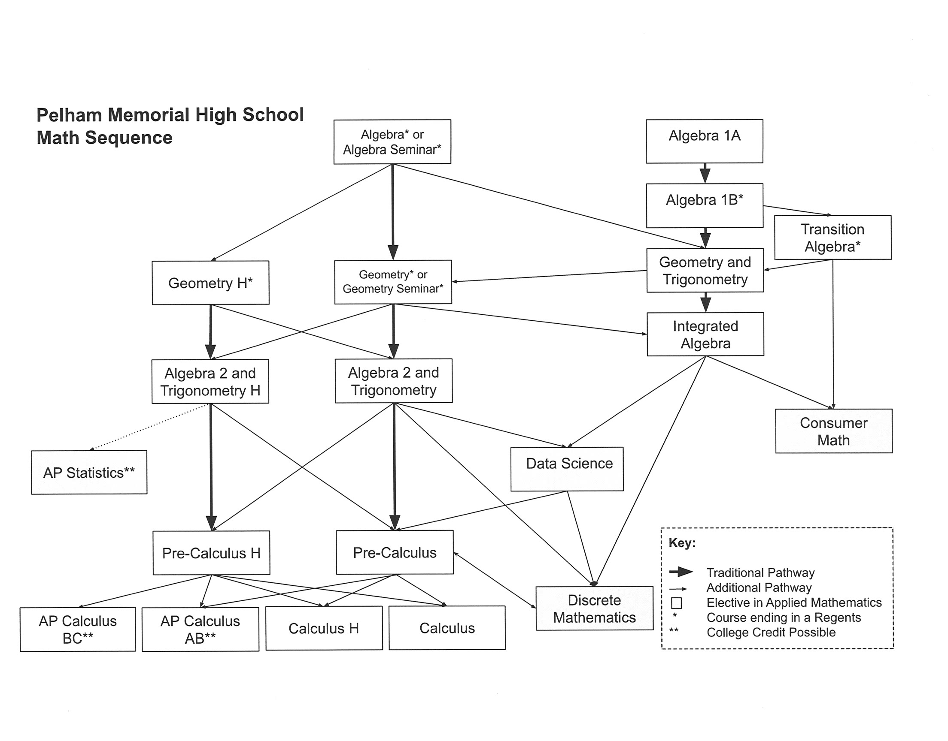
MATHEMATICS DEPARTMENT

We recommend that both parents and students consider the following when selecting a math course.

- Progress and/or grade in current math class
- Current Math Teacher’s recommendation
- Overall course load and extracurricular commitments
- The additional rigor inherent in movement to higher level mathematics

In recent years there have been many changes in our approach to teaching mathematics. These include instructional strategies, curriculum content, course sequencing and new assessments. The new NYS high school curriculum and assessments are all currently phased in. These changes continue to raise the academic bar for all students. Pelham Memorial High School’s mathematics program reflects these changes and strives to provide an appropriate and challenging math program for all students.

Our program includes:
♦ Accelerated, honors and advanced placement programs.
♦ Academic support.
♦ Opportunities to participate in the Westchester County HS Math League and other local math competitions.
♦ Extensive support from the teachers in the mathematics department.
♦ A National Mathematics Honor Society

Most students take a four-year course of study in mathematics. All students are required to pass the Algebra Regents Examination to meet the graduation requirement. The study of mathematics is sequential and as such, requires an understanding of content taught in previous courses. The prerequisite for many courses is successful completion of the previous course in the sequence. We strongly recommend that students not meeting those standards consider altering their program in favor of one that will allow them to achieve a high level of success and a strong mathematical background. Please note that AP course guides from The College Board are available by clicking on each AP listing.

ALGEBRA 1A Prerequisite: Math 8
1 Credit

This course is the first year of a two-year program in the Common Core Algebra. The Common Core Algebra Regents will be administered at the end of the 2nd year. The topics include: operations with real numbers, number properties and number systems, simple algebraic expressions, linear equations, systems of linear equations, set theory, ratio and proportion, and statistics. The T-84+ graphing calculator is used very frequently and is strongly recommended for the course. Please note that Algebra is typically offered as a one year course.

ALGEBRA 1B Prerequisite: Algebra 1 A
1 Credit

This course is the second year of a two year program in Common Core Algebra. The topics include: solving word problems algebraically, using algebra in geometric formulas, operations with exponents, solving inequalities, operations with algebraic expressions, probability, special products and factors, algebraic fractions, radicals, quadratic equations, and trigonometry of the right triangle. The TI-84+ graphing calculator is used very frequently and is strongly recommended for the course. Students will take the Common Core Algebra Regents exam in June.

ALGEBRA 1 Prerequisite: Math 8
1 Credit

Algebra is the first mathematics course in the high school. Topics include: operations with real numbers, number properties and number systems, simple algebraic expressions, linear equations, systems of linear equations, set theory, ratio and proportion, statistics, solving word problems algebraically, using algebra in geometric formulas, operations with exponents, solving inequalities, operations with algebraic expressions, probability, special products and factors, algebraic fractions, radicals, quadratic equations, coordinate geometry and trigonometry of the right triangle. This course will assist students in developing skills and processes to be applied using a variety of techniques to successfully solve problems in a variety of settings and content areas. Students will take the Common Core Algebra Regents in June. The TI-84+ graphic calculator is used very frequently and is strongly recommended for the course.
ALGEBRA w/SEMINAR

This course is a non-credit course that may be taken in conjunction with Algebra 1. The Algebra Seminar class is designed to support students in the acquisition of new Algebra content and to support students in strengthening skills that have been previously taught.

TRANSITION ALGEBRA

This course will prepare students to meet the graduation requirement of successfully passing the New York State Common Core Algebra Regents Exam through targeted remediation. Topics of study include a review of basic Algebra skills and then continue with the New York State Common Core Algebra Curriculum.
The TI-84+ graphing calculator is used frequently and is strongly recommended for the course.

GEOMETRY AND TRIGONOMETRY Prerequisite: Completion of Algebra or Algebra 1B
1 Credit

Geometry and Trigonometry is an introductory course in Geometry and Trigonometry. Topics in this course parallel the topics in most Geometry, with a special emphasis on content and relationships, rather than proof and reasoning. Topics include: angle measurement, congruent triangles, coordinate geometry, transformational geometry, circle relationships and right triangle trigonometry. There is no Regents exam associated with this course.

GEOMETRY Prerequisite: Completion of
1 Credit Algebra 1, Algebra 1B or
Geometry & Trigonometry

Geometry is the second course in mathematics for high school students. Within this course, students will have the opportunity to make conjectures about geometric situations and prove in a variety of ways, both formal and informal, that their conclusion follows logically from their hypothesis. This course is meant to employ an integrated approach to the study of geometric relationships. Integrating transformational and coordinate approaches to geometry, students will justify geometric relationships and properties of geometric figures. Congruence and similarity of triangles will be established using appropriate theorems. Transformations including rotations, reflections, translations, and glide reflections and coordinate geometry will be used to establish and verify geometric relationships. Students will take the Common Core Geometry Regents in June. The TI-84+ graphing calculator is used very frequently and is strongly recommended for the course.

GEOMETRY w/SEMINAR Prerequisite: Algebra, Algebra
1 Credit 1B or Geometry and Trigonometry
Geometry is the second course in mathematics for high school students. This course is linked with a Geometry Seminar class three days of every six day cycle, resulting in additional contact time with the teacher. Within this course, students will have the opportunity to make conjectures about geometric situations and prove in a variety of ways, both formal and informal, that their conclusion follows logically from their hypothesis. This course is meant to employ an integrated approach to the study of geometric relationships. Integrating transformational and coordinate approaches to geometry, students will justify geometric relationships and properties of geometric figures. Congruence and similarity of triangles will be established using appropriate theorems. All students will take the Common Core Geometry Regents exam in June. The TI-84+ graphing calculator is used very frequently and is strongly recommended for this course.

GEOMETRY H Prerequisite: Algebra I
1 Credit

We have found students to be more successful in Geometry Honors if they meet the following guidelines: score in the levels of 3, 4 or 5 on the 8th Grade Math Assessment and receive midterm examination, final examination and final grades of 90% or higher in Algebra I. We also recommend that parents and students discuss this placement with the child’s current mathematics teacher and school counselor.

Students will continue their study of HS Mathematics at the honors level in Geometry H. Within this course, students will have the opportunity to make conjectures about geometric situations and prove in a variety of ways, both formal and informal, that their conclusion follows logically from their hypothesis. This course is meant to employ an integrated approach to the study of geometric relationships. Integrating transformational and coordinate approaches to geometry, students will justify geometric relationships and properties of geometric figures. Congruence and similarity of triangles will be established using appropriate theorems. Transformations including rotations, reflections, translations, and glide reflections and coordinate geometry will be used to establish and verify geometric relationships. Students will take the Common Core Geometry Regents in June. The TI-84+ graphing calculator is used very frequently and is strongly recommended for the course.

INTEGRATED ALGEBRA Prerequisite: Geometry Seminar or
1 Credit Geometry and Trigonometry

Integrated Algebra is a year-long college preparatory mathematics course. Students will study advanced Algebra topics including equation solving, rational expressions, linear and quadratic functions, system of equations, complex numbers, logarithms and trigonometry.
The TI-84+ graphing calculator is used very frequently and is strongly recommended for the course.
ALGEBRA 2 & TRIGONOMETRY Prerequisite: Geometry, Geometry H or
1 Credit Geometry Seminar

This course is the third in a sequence following Algebra and Geometry for high school students on a college preparatory pathway. Students who enroll in this course typically demonstrate success in the two Regents level courses that precede it. The curriculum in this course includes additional study of linear, quadratic, and exponential functions. It also includes an investigation of complex numbers, polynomials, logarithms, advanced trigonometry, and select topics in statistics. The TI-84+ graphing calculator is used frequently and is strongly recommended for this course.

ALGEBRA 2 & TRIGONOMETRY H Prerequisite: Geometry, Geometry H or
1 Credit Geometry Seminar

This course is the third in a sequence following Algebra and Geometry for high school students on a college preparatory pathway. Students who enroll in this course typically demonstrate success in the two Regents level courses that precede it. The curriculum in this course includes additional student of linear, quadratic, and exponential functions. It also includes an investigation of complex numbers, polynomials, logarithms, advanced trigonometry, and select topics in statistics. The honors level course includes units of study beyond the non honors level, including advanced trigonometry, and moves at a faster pace to cover these additional topics.
The TI-84+ graphing calculator is used frequently and is strongly recommended for this course.

PRE-CALCULUS Prerequisite: Algebra 2/Trigonometry,
1 Credit Algebra 2/Trigonometry H

Pre-Calculus focuses on the study of functions and their applications. Topics include polynomial, rational, exponential and trigonometric functions and their applications. The course also includes introduction to limits and select topics in statistics. The TI-84+ graphing calculator is required and used extensively throughout the course.

PRE-CALCULUS H Prerequisite: Algebra 2/Trigonometry
1 Credit H or Algebra 2/Trigonometry

Pre-Calculus Honors focuses on the study of functions and their applications. Topics include polynomial, rational, exponential and trigonometric functions, polar coordinates, introduction to parametric equations and select topics in statisticss. In addition, this course introduces students to calculus including limits and the definition of the first derivative. Students will be expected to apply their knowledge of mathematics in problems which require making connections between and among mathematical concepts. This intensive course will prepare the students for the rigors of the Calculus AP program. The TI-84+ graphing calculator is required and used extensively throughout the course.
CONSUMER MATHEMATICS
1 Credit

This course will assist students in learning to use mathematics effectively as a tool in their personal and business lives. How effectively one is able to use mathematics may determine how well one is able to prepare for the future, manage one’s personal and business resources and benefit from one’s efforts as a consumer, worker or business person. Topics include: retail mathematics including buying and selling, personal business mathematics including wages and payroll, checking and savings accounts, charge accounts and credit cards, loans, housing costs, automobile costs and taxes.
DATA SCIENCE Prerequisite: Integrated Algebra or
1 Credit Algebra 2/Trigonometry

This course is designed to examine the use of mathematics in society to drive decision making. In our world, data is often used to present evidence in favor of or against specific options. From political polls to stock market and consumer confidence measures, people are asked to process data to determine what makes sense. Data Science is a course that seeks to empower individuals with the critical thinking and problem solving skills needed to interpret numbers in order to reach their own informed conclusions on issues and sort out misinformation from reliable data.
DISCRETE MATHEMATICS Prerequisite: Intermediate Algebra or
1 Credit Algebra 2/Trigonometry

This course will prepare students for a college level course in discrete, finite, or applied mathematics. Topics such as: matrices, logic, game theory, voting methods, apportionment, and graph theory will be covered. These less traditional topics are often found in typical college level courses and serve as a great foundation to many areas of study. In addition, a review and extension of some more traditional algebraic concepts like exponential and logarithmic functions, as well as probability will be addressed. These topics are integral to real world applications in finance and games of chance, which are also covered. Throughout the course emphasis will be placed on improving problem-solving skills, creating models for real-world applications, and using technology.
Students are required to have a TI-84+ graphing calculator.

CALCULUS Prerequisite: Pre- Calculus or Pre-Calculus H
1 Credit

This full-year course continues with the study of functions and limits with an emphasis on analysis and applications. The course will build upon the concept of a rate of change by defining the derivative. Various techniques of differentiation will be covered. The course will prepare students for further study of calculus at the college level. Students are required to have a T1-84+ graphing calculator.

CALCULUS HONORS Prerequisite: Pre- Calculus or Pre-Calculus H
1 Credit

Students will continue their study of high school mathematics in Calculus Honors. This full-year course extends the study of functions and limits from Pre-Calculus with an emphasis on analysis and applications. The course will build upon the concept of a rate of change by defining the derivative. Various techniques of differentiation will be covered and the concept of integration will be introduced. The course will prepare students for further study of calculus at the college level.
Students are required to have a T1-84+ graphing calculator.

AP CALCULUS AB & BC Prerequisite: Pre- Calculus or Pre-Calc H
1 Credit

This full-year course is the equivalent to a first semester college course in calculus and is the culmination of
a rigorous mathematics course of study at the high school level. The course continues with the notion of limit behavior and its applications, specifically, rates of change and areas under curves. The fundamental understanding of these concepts will assist in the understanding of the derivative and the integral. Emphasis throughout will be more on the approach to modeling, analyzing, and solving problems, rather than the ability to manipulate or memorize. In this course, students will focus on being able to interpret and verify conclusions graphically, numerically and verbally.
Students are required to have a T1-84+ graphing calculator.
*Students enrolled in this class MUST sit for the AP Exam in May.*
Calculus BC is an extension of Calculus AB and includes all the Calculus AB topics in addition to: integration by parts and improper integrals, analyzing parametric, polar, and vector functions as well as calculating derivatives and integrals (areas between curves) for each type and polynomial approximations using series (Maclaurin and Taylor). Technology will be used extensively throughout both courses.
Calculus BC is dependent on enrollment.
Students are required to have a TI-84+ graphing calculator.
*Students enrolled in these classes MUST sit for the AP Exam in May.*

AP STATISTICS Prerequisite: Geometry
1 Credit Co-requisite: Algebra 2

This full year course is equivalent to a first semester college level introductory statistics course. Topics include: Exploring Univariate Data; Correlation and Linear Regression; Modeling Non-linear Data; Categorical Data Distributions; Sampling Techniques; Experimental Design; Introduction to Simulation; Probability; Random Variables; Binomial and Geometric Distributions; Confidence Intervals; Significance Tests for Means; Proportions and Categorical Distributions (Chi-Squared Test); and Inference for Regression. Students are required to have TI-84+ graphing calculator.
*Students enrolled in this class MUST sit for the AP Exam in May.*

MUSIC DEPARTMENT

CONCERT CHORUS
1 Credit or ½ Credit with Band, Orchestra or Chamber Chorus

Concert Chorus students engage in the process of learning proper vocal technique, diction, musicianship training which includes theory, music history and sight reading. Students will experience and perform a wide variety of Choral music from different styles, periods, and languages. Performances at evening Winter and Spring concerts and in the High School assembly programs are mandatory. Sectionals (group lessons) are a requirement of all Chorus students. These lessons provide students with the opportunity to develop specific techniques through differentiated instruction. Sectionals are essential to student success in individual performance and ensemble contribution.

CHAMBER CHORUS Prerequisite: Solo auditions
1/2 Credit 1 year of concert chorus
Grades 10-12

Students in the Chamber Chorus will experience the art of Choral music through the study and performance of historically significant choral literature. Continued growth towards advanced music literacy will be achieved through analysis of the elements of music during rehearsals and through weekly homework assignments. Performance at evening Winter and Spring concerts and in the High School assembly programs are mandatory as well. The Chamber Chorus is also expected to perform at the NYSSMA Major Organizational Festival.

BAND Prerequisite: Instrumental experience
1 Credit or ½ Credit from previous grade or audition

Performance of various types of band music from all periods is undertaken. Participation includes the marching and concert bands. Attendance at all performances is mandatory and outside practice is also required. The group performs at all football games, some parades, schools assemblies, and holiday and spring concerts, as well as other special occasions. The group also meets in various small ensembles to explore other literature. Pull-out sectionals are mandatory.

JAZZ BAND (FORMERLY STAGE BAND) Prerequisite: Ability to read music and audition
1/2 Credit

The jazz band is a 20+ piece ensemble patterned after the Big Bands of the Swing Era. Jazz styles from Swing to Latin, ballads to jazz and rock are played. The band performs many times during the school year in and out of school.

ORCHESTRA Prerequisite: Ability to read music and audition
1 Credit
½ Credit with Band or Chorus

Orchestra students engage in the processes of preparation for and performance of concerts. While in preparation, students develop skills and rehearsal techniques necessary for ensemble playing. Through individual practice, students become more proficient in their instruments. Sectionals (group lessons/rehearsals) are a requirement of all string students. These lessons provide students with the opportunity to develop specific techniques through differentiated instruction. Sectionals are essential to student success in individual performance and ensemble contribution.

MUSIC THEORY 1 Prerequisite: Ability to read music
½ Credit

This course is an introduction to basic musicianship, theory and the musical elements. Melody, harmony, texture, rhythm, form, musical analysis, elementary composition, history and style, dictation and other listening skills, sight-singing, and keyboard harmony are considered an important part of this course. The student’s ability to read and write musical notation is fundamental. It is also strongly recommended that the student will have acquired basic (at least) performance skills in an instrument.

PHYSICAL EDUCATION DEPARTMENT

The Pelham Memorial High School Physical Education department curriculum philosophy is based on the following standards: A physically educated person:

1. Demonstrates competency in many movement forms and proficiency in a few movement forms.
2. Applies movement concepts and principles to the learning and development of motor skills.
3. Exhibits a physically active lifestyle.
4. Achieves and maintains a health-enhanced level of physical fitness.
5. Demonstrates responsible personal and social behavior in physical activity settings.
6. Demonstrates understanding and respect for differences among people in physical activity settings.
7. Understands that physical activity provides opportunities for enjoyment,
challenge, self-expression, and social interaction.

The high school physical education department offers four strands of physical education courses. A student chooses one of these strands to participate in each year of their high school career. The student may switch strands from year to year.

COMPETITIVE SPORTS (Grades 9/10, 11/12)
½ Credit each course
Students are given opportunities to participate in a large range of team and individual competitive games and activities. Skills and strategies are taught and assessed.

LIFETIME SPORTS AND FITNESS (Grades 9/12)
½ Credit
Students are given opportunities to participate in a wide variety of fitness based activities. Lifetime sports are incorporated into the program where appropriate. Students are assessed on fitness related concepts. This
program is not competitive in nature.

“PECS” (Physical Education Challenge and Skill) (Grades 10, 11, 12)
½ Credit
This strand is for the students who desire a more intense level of competition. The curriculum includes more advanced skills and strategies. Students are also encouraged to participate in a mentoring program. This
program gives the students an opportunity to work with the middle school physical ed staff and their classes.

THE SCIENCE OF COACHING
½ Elective unit
The Science of Coaching is a semester length course in which students study the science, engineering and technology underlying great athletic performance and coaching including: design and testing of athletic equipment, statistical analysis of individual and team performance and exercise physiology. As part of this class, students will complete an internship where they will apply what they have learned.

HEALTH SCIENCE Open to Sophomores, Juniors
½ Credit and Seniors

This required course attempts to develop positive attitudes and knowledge concerning the human, which enhances an individual’s physical, social, and emotional wellbeing. Topics that are discussed include drugs in our society, alcoholism, mental health, eating disorders, nutrition/physical fitness, stress and stress reduction, human sexuality, HIV/AIDS, and sexually transmitted infections. The focus of health education is taking responsibility for your own health by promoting informed decision-making.

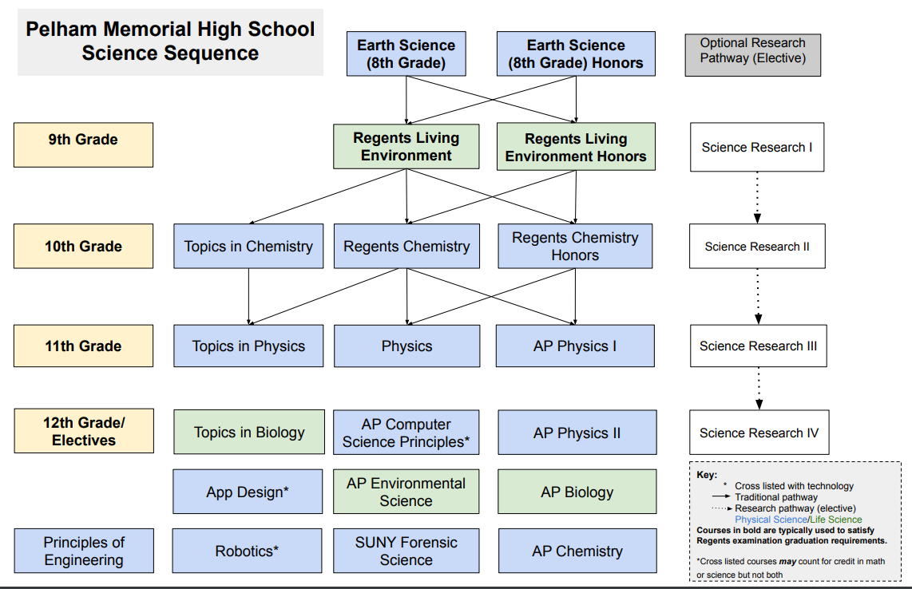
AP Biology AP Physics I & II
AP Chemistry Robotics
Computer Science Topics in Chemistry
AP Environmental Topics in Physics
SUNY Forensic Science

SCIENCE DEPARTMENT
LIVING ENVIRONMENT REGENTS Prerequisite: Physical Setting:
1 Credit Earth Science

This course is designed to provide students with an understanding of fundamental biological principles and concepts. It consists of topics ranging from cell biology to ecological sustainability. Students enrolled in the course will complete the mandated laboratory assignments established by New York State along with additional lab experiences that expose students to key ideas in life science. The Living Environment course will also include creative projects that allow students to investigate connections between biological concepts and real world phenomena. Following the completion of this course, students will take the Living Environment Regents Examination in June.

LIVING ENVIRONMENT HONORS Prerequisite: Physical Setting:
1 Credit Earth Science

This course is designed to provide students with an in-depth understanding of fundamental biological principles and concepts. It consists of selected, extended areas of biology including biochemistry, genetics, and experimentation as well as the New York State core curriculum requirements. The extended areas will stress independent and collaborative work involving more extensive and quantitative laboratory activities, research and group discussions. Additional topics may include phylogeny, genetic expression and trait linkage, photosynthetic reactions, cellular metabolic pathways, and mechanisms of plant reproduction. Other possible assessments may include creative projects, position papers, book reviews, and independent laboratory experiments. These students will take the Living Environment Regents Examination in June.

PHYSICAL SETTING: CHEMISTRY REGENTS Prerequisite: Living Environment and
1 Credit Algebra 1, Algebra 1B

This is a laboratory-oriented course developed in accordance with the New York State core curriculum using theory and fundamental mathematical skills. It deals with the interrelationships between matter and energy, with the emphasis on matter. Appropriate laboratory experiences are designed to enhance students’ understanding of basic chemical principles. Core topics include: Atomic Concepts, Periodic Table, Moles
/Stoichiometry, Chemical Bonding, Physical Behavior of Matter, Kinetics/Equilibrium, Organic Chemistry, Oxidation-reduction, Acids and Bases, and Nuclear Chemistry. The course terminates with the Regents exam.

PHYSICAL SETTING: CHEMISTRY HONORS Prerequisite: Living Environment,
1 Credit Algebra

This course covers the material in the New York State Physical Setting: Chemistry Core and the extended units required to take the SAT Chemistry subject test. It stresses a laboratory approach. Laboratory experiments require broader skills and more extensive analyses that show their creative as well as their scientific skills. The course work stresses independent thought and work. Some additional concepts covered include Hund's Rule, Ideal Gas Law, VSPER Model, Hess' Law, and calculating pH values. Students may be required to complete additional science projects or long term enrichment assignments. Unit test questions will mirror the format of the Chemistry Regents and SAT Chemistry subject test. This course terminates with a New York State Regents examination.

PHYSICAL SETTING: PHYSICS Prerequisite: Living Environment,
1 Credit Chemistry Regents,
Algebra 1, Geometry

This course examines the laws of physics from the subatomic through the cosmic levels. Inherent in this course is an appreciation for the discoveries of past scientists including Galileo, Kepler, Newton, Faraday, Curie, and Einstein. The course covers five major topics: mechanics, energy, wave phenomena, electricity and
magnetism, and modern physics. This course reviews all the math skills needed by the students to be successful in physics and enjoy the course.

TOPICS IN CHEMISTRY
1 Credit
Prerequisite: Living Environment

Topics in Chemistry is a STEM project-based course covering the core areas of Chemistry including: atomic structure and bonding, the behavior of matter including thermodynamics, acids and bases, and specialty areas of environmental and culinary chemistry. Students will have an opportunity to develop their applied skills before joining Regents Chemistry the following year.

TOPICS IN PHYSICS
1 Credit Prerequisite: Living Environment
This course is designed to provide students with a general understanding of the major concepts that describe the principles of physics in our world. The knowledge gained should ultimately allow students to apply the concepts to everyday experiences and appreciate the study of physics as an endeavor to better understand the universe and the natural phenomena that are a part of it.

TOPICS IN BIOLOGY
1 Credit Prerequisite: Living Environment
This course is designed to provide students with an understanding of contemporary issues in life science. The class will explore real world problems ranging from climate change and ecological conservation to other newsworthy topics like pandemics, alternative energy sources, genetic engineering, and bioethics. The purpose of this course is to develop scientifically literate students who can engage in the great life science debates of our time.

PRINCIPLES OF ENGINEERING
1 Credit Prerequisite: Living Environment
Principles of Engineering will serve as an introduction to engineering for students interested in identifying problems and designing solutions to those problems using science, math, art, and technology. Students in this course will explore real world issues and take a project based approach in answering them. Participants will be expected to think critically about problems and create solutions by drawing on new ideas, research, and their own experiences. The practical aspects of addressing problems will be discussed along with the aesthetic repercussions of creating original designs.

ADVANCED PLACEMENT/COLLEGE LEVEL COURSE DESCRIPTIONS
Students should have completed at least three Regents Level Sciences. Juniors interested in taking AP courses may do so in conjunction with Physics. Some seniors may opt to take two science AP electives. It is strongly recommended that interested students should speak to a school counselor, a science teacher, and their parents before they enroll in any advanced placement course. As with all college courses, the student is expected to have a mastery level understanding of the basic Regents courses. These courses vary in difficulty level and the science department strongly encourages your participation in at least one AP course. The curriculum for all AP Science Courses follows guidelines established by the AP College Board. (www.collegeboard.com). SAT subject area tests can be taken after the appropriate subject area AP.

AP PHYSICS 1 & AP PHYSICS 2
The Advanced Placement Physics I and II courses will provide willing and academically prepared students a sequential systemic introduction to the main principles of college-level physics and emphasizes the development of problem solving ability and reasoning skills. For both courses, it is assumed that the student is familiar with algebra and trigonometry; calculus is seldom used, although some theoretical developments may use basic concepts of calculus. Focusing on these skills allows for the application of principles and use of scientific inquiry to promote a more engaging and rigorous experience for AP Physics students.

AP PHYSICS 1: ALGEBRA BASED Prerequisite: Algebra 1, Geometry,
Algebra 2, Chemistry Regents
AP Physics 1 is a yearlong introductory course equivalent to a first-semester college course in algebra-based physics. The course covers Newtonian mechanics (including rotational dynamics and angular momentum); work, energy, and power; and mechanical waves and sound. It will also introduce electric circuits. The AP Physics 1 exam will be taken in May.

AP PHYSICS 2: ALGEBRA BASED Prerequisite: AP Physics I

AP Physics 2 is a yearlong course equivalent to a second-semester college course in algebra-based physics. This course will serve as a continuation of AP Physics 1 focusing on electricity & magnetism and modern physics components. More lab activities and the inclusion of additional topics such as thermodynamics and fluid dynamics. Students must take the AP Physics 2 exam in May.

AP ENVIRONMENTAL SCIENCE Prerequisite: Living Environment,
1 Credit Chemistry, Algebra & Geometry Regents,
Regents level math.

The AP Environmental Science course is an interdisciplinary experience which embraces a wide variety of topics from different areas of environmental study. This exciting course is for students interested in gaining an understanding of the scientific principles underlying the Earth’s natural ecosystems and the implications of human impact on these ecosystems. This course includes a strong laboratory and field investigation component. Students learn about the environment through first hand observation. These diverse experiments provide students with important and enjoyable opportunities to test concepts and principles that are introduced in the classroom. Students acquire skills in techniques such as water sample analysis, investigating global temperature changes, and human population dynamics through data analysis. All students must sit for the AP Exam in May.
AP BIOLOGY Prerequisite: Successful completion of Living
1 Credit Environment, Physical Setting: Chemistry, 2 years Regents level math

The AP Biology course is designed to be taken by students after the successful completion of a first course in high school biology and one in high school chemistry. It aims to provide students with the conceptual framework, factual knowledge, and analytical skills necessary to deal critically with the rapidly changing science of biology. The two main goals of AP Biology are to help students develop a conceptual framework for modern biology and to help students gain an appreciation of science as a process. The ongoing information explosion in biology makes these goals even more challenging. Primary emphasis in an Advanced Placement Biology course should be on developing an understanding of concepts rather than on memorizing terms and technical details. Essential to this conceptual understanding are the following: a grasp of science as a process rather than as an accumulation of facts; personal experience in scientific inquiry; recognition of unifying themes that integrate the major topics of biology; and application of biological knowledge and critical thinking to environmental and social concerns. All students must sit for the AP Exam in May. This course will prepare students for portions of the SAT Subject test exam in Biology.

AP CHEMISTRY Prerequisite: Successful completion of Living
1 Credit Environment, Chemistry & Physics*, 2 years Regents level math**

AP Chemistry is a yearlong course equivalent to a college level general chemistry class. Students in such a course should attain a depth of understanding of fundamentals and a reasonable competence in dealing with chemical problems. The course should contribute to the development of the students’ abilities to think clearly and to express their ideas, orally and in writing, with clarity and logic. The college course in general chemistry differs qualitatively from the usual first secondary school course in chemistry with respect to the kind of textbook used, the topics covered, the emphasis on chemical calculations and the mathematical formulation of principals, and the kind of laboratory work done by students. Quantitative differences appear in the number of topics treated, the time spent on the course by students, and the nature and the variety of experiments done in the laboratory. The importance of the theoretical aspects of chemistry has brought about an increasing emphasis on these aspects of the content of general chemistry courses. Topics such as the structure matter, kinetic theory of gases, chemical equilibria, chemical kinetics and the basic concepts of thermodynamics are now being presented in considerable depth. All students must sit for the AP Exam in May. The students will be prepared to take the SAT Chemistry subject test at the end of this course.

*may be taken concurrently with Physics
**may be taken concurrently with Pre-Calculus Honors

FORENSIC SCIENCE w/Lab (SUNY) Prerequisite: Completion of Living
1 credit (4 college credits) Environment and
*Seniors only Chemistry Regents

Forensic Science is an introductory college level course offered by the Pelham science department in cooperation with the Chemistry department at Westchester Community College (WCC). Students who enroll in this course must pay the WCC discounted tuition rate (approximately $250/course), which is 1/3 of the college's standard tuition charge. Once the student successfully completes the course he/she is entitled to a SUNY transcript of the credits earned. The course includes lectures, laboratory, simulation activities and projects on a variety of forensic science content areas. The areas include performing forensic autopsies, entomology, traumatic death analysis, forensic toxicology and poisonings, identification of remains through teeth and bones, scattered remains recovery, crime scene investigations for outdoor and indoor scenes, blood spatter analysis, latent fingerprints, interviewing witnesses and interrogation techniques, forensic psychology and criminal profiling of serial killers.

SCIENCE RESEARCH PROGRAM (affiliated with the University at Albany - SUNY)
Science Research is a four-year program in which students investigate an area of science and perform original research projects with qualified scientists. This program offers a unique opportunity for students allowing them to work at the forefront of discovery. Students are able to conduct investigations in all areas of the biological, chemical, physical, and social sciences. Students work side-by-side with researchers at college, university and medical school laboratories attempting to solve some of the most perplexing problems society faces today. In the process, students develop many academic and personal skills that will be of lifelong benefit. The culmination of their work is a scientific research paper. This paper is entered into the Siemens, Intel Science Talent Search, as well as other science competitions determined by grade level. Students are expected to actively participate in and organize the Annual Science Research Symposium during which they will present their work and coordinate the publication of the Pelham Science Research Journal. Students can earn up to 12 college credits – starting the summer entering junior year. The cost for each SUNY Albany course is approximately $150.

Attendance at Science Competitions and Symposia is MANDATORY
Science Research I
1 Credit (Freshmen Only) Prerequisite: Summer Assignment
This is the first course in a four-year sequence that creates the foundation necessary for students to be successful in their future research experience. Working both individually and in small groups, students engage in the scientific method through a variety of short and long term science experiments. Students learn the basics of journal article comprehension, writing research papers, statistical analysis and public speaking. As freshmen, students work in our Biotechnology Lab, where they demonstrate various skills they learn about in their Living Environment classes, such as DNA amplifications via Polymerase Chain Reaction, Restriction Enzyme Analysis, Bacterial Transformations, and Culture and Identification of Bacteria. Students also learn how to prepare reagents, perform sterile techniques, and run and maintain a biotechnology laboratory.
Science Research II
1 Credit (Sophomores Only) Prerequisite: Science Research I
Students are given the opportunity and supported in conducting research in various STEM fields: science, technology, engineering, and mathematics. Once a significant amount of background research is performed and a strong sense of understanding is gained, the student contacts a research scientist within their field of interest. The initial stages of their research experience commences during the spring and summer. Students also participate in multiple competitions as they prepare for junior and senior year.
Science Research III & IV
1 Credit (Juniors and Seniors Only) Prerequisite: Science Research II/III
Through collaboration with their mentors and research director, juniors and seniors further design and conduct authentic science research. All steps in the student’s progress are carefully and systematically monitored to assure that students engage in each phase of scientific research and have completed the requirements of the program. Attendance and participation in the Regional Intel ISEF competition which may fall on the same day as the March SAT is mandatory. Students are required to finalize the writing of their scientific research paper and potentially publish their paper. Papers must be entered into all available science competitions (Intel STS, SIEMENS, Intel ISEF (WESEF), and JSHS.) The findings of these papers will be presented to the class, school district, and at regional and statewide symposia.

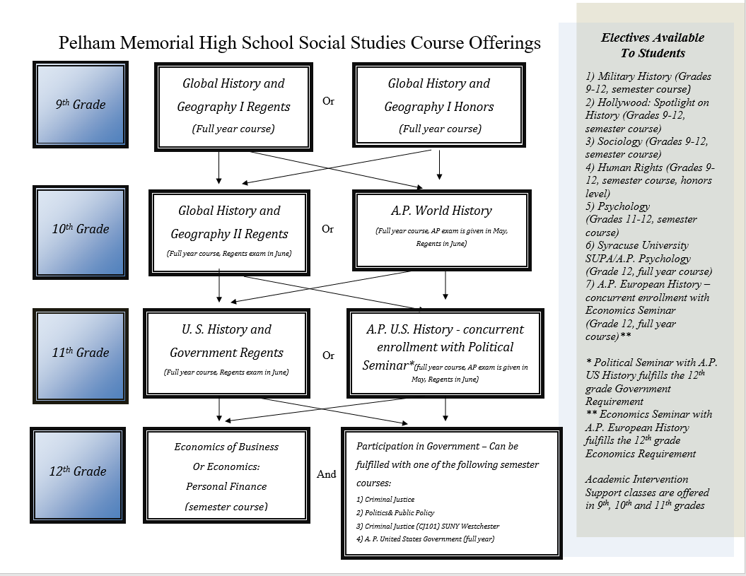
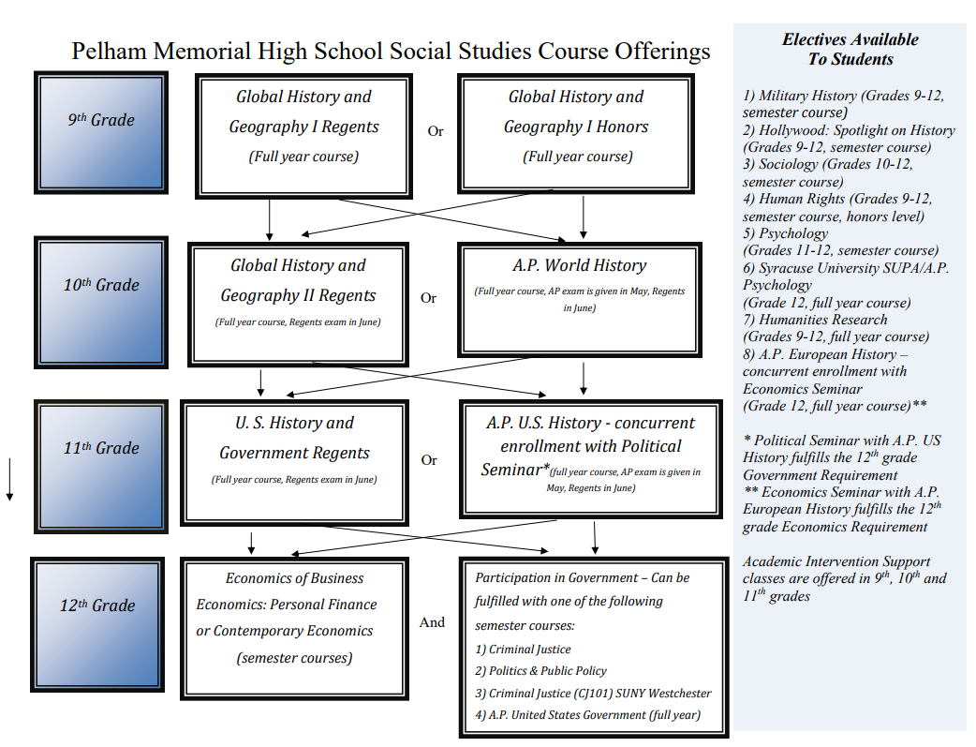
SOCIAL STUDIES DEPARTMENT

Social Studies courses offered to Pelham students follow the New York State Core Curriculum and recognize the diversity of interests, needs, and abilities within the student body. The social studies department views as its responsibility the preparation of students to meet the challenges of a pluralistic, rapidly changing and increasingly interdependent world. In addition to preparing students to participate fully as citizens in a democratic society, the department members believe that a lifetime interest in social studies improves quality of life, whether or not the student follows a career in the field.

Individual needs of students are met by providing, in addition to Regents courses, an Honors program, including five Advanced Placement courses, one SUNY Westchester course, and one Syracuse University Project Advance (SUPA) course. Students whose work indicates the need for remediation will be recommended for Academic Intervention Labs. At the end of 10th grade, social studies students take a Regents exam covering Global History and Geography II. The United States History and Government Regents exam is administered following that course at the end of 11th grade.

SOCIAL STUDIES COURSE DESCRIPTIONS

GLOBAL HISTORY & GEOGRAPHY I REGENTS
Grade 9
Prerequisite: Social Studies 8
1 Credit (full-year course)

The first year of the two-year sequence, Global History and Geography I Regents, is organized as a chronological study of World History, from the beginning of civilization through Early Modern History (Approx. 1750). The course will address history, geography, economics, and government, and, where appropriate, it will draw connections across regions and time periods. Primary sources related to each unit also will be used to practice skills and prepare students for the Regents exam at the end of Global History and Geography II.
Link to New York State curriculum: https://www.engageny.org/resource/new-york-state-k-12-social-studies-framework

GLOBAL HISTORY & GEOGRAPHY I HONORS
Grade 9
Prerequisite: Social Studies 8
1 Credit (full-year course)

This course covers the ninth-grade Global History and Geography I content in greater depth. The course is designed to develop a greater understanding of the evolution of global processes and contacts in interaction with different types of human societies over time. This understanding is achieved through a combination of selective factual knowledge and analytical skills. The course highlights the nature of changes in international frameworks and their causes and consequences, as well as comparisons among major societies. Summer reading is suggested prior to entry into the class. Requirements include: essay and objective exams, class participation and discussion, at least two research papers, various learning projects, and textbook/supplemental readings.
Link to New York State curriculum: https://www.engageny.org/resource/new-york-state-k-12-social-studies-framework

GLOBAL HISTORY & GEOGRAPHY II REGENTS
Grade 10
Prerequisite: Global History & Geography I

The second year of the two-year sequence continues the chronological study of World History from 1750 through the contemporary period. The impact of revolution, nationalism, imperialism, industrialization, modernization, and war on the Western and non-Western countries will form the core of the course of study. Emphasis will be given to the examination of concepts, the analysis of factual content, and the improvement of skills, especially gathering and evaluating information from primary sources, in preparation for the Regents exam at the end of the course. Link to New York State curriculum: https://www.engageny.org/resource/new-york-state-k-12-social-studies-framework

WORLD HISTORY AP
Grade 10
Prerequisite: Global History & Geography I
1 Credit (full-year course)

This is a challenging, college-level history course that seeks to help students understand the larger patterns of human history from roughly 8000 B.C.E. to the present day. AP World History focuses less on individual nations or regions and instead focuses on patterns of interaction and shared experiences between societies. For example, the course concentrates both on how peoples of the world came together at significant places and times as well as how different groups of people shared and developed processes that might not have included direct interaction. Themes are explored in order to better see large-scale patterns throughout the course. Summer reading is suggested prior to entry into the class. All students sit for the AP Examination in May and the Global Regents examination in June. This course will prepare students for portions of the SAT
Subject test in World History. Requirements include: essay and objective exams, class participation and discussion, at least two research papers, various learning projects, and textbook/supplemental readings.
Link to New York State curriculum: https://www.engageny.org/resource/new-york-state-k-12-social-studies-framework
Link to College Board for AP World History: https://apstudent.collegeboard.org/apcourse/ap-world-history

UNITED STATES HISTORY & GOVERNMENT REGENTS
Grade 11
Prerequisite: Global History & Geography I & II
1 Credit (full-year course)

This course explores the development of the American Nation. The first semester begins with a study of American government in theory and practice, followed by a chronological survey of westward expansion, Native American policy, relative isolationism, slavery, civil war, reconstruction, industrialization, immigration and the onset of American Imperialism. The second semester is devoted to 20th and 21st Century American history, both domestic and foreign. Social, political and cultural development will be reviewed with a continuing connection to current events. Daily assignments are supplemented with original source reading, analysis, and discussion. Students are expected to do a significant amount of work on their own.
Link to New York State curriculum: https://www.engageny.org/resource/new-york-state-k-12-social-studies-framework

UNITED STATES HISTORY AP
Grade 11
Prerequisite: Global History & Geography I & II
1 Credit (full-year course)

This college-level course provides students with the analytical skills and factual knowledge to deal critically with United States history and makes the same demands on them as a full year introductory college course. Students will learn to assess historical materials, their relevance to a given problem, and their reliability and importance. Students will learn to weigh the evidence and interpretations presented in historical scholarship. The course will help students develop the skills necessary to arrive at conclusions on the basis of an informed judgment and to present reasons and evidence clearly and persuasively in essay format. Extensive reading and writing are required. All students take the AP examination in May and sit for the Regents Exam in June. This course will prepare students for portions of the SAT Subject test in US History. Students taking this course will participate in a Political Process seminar which will satisfy the ½ credit Participation in Government graduation requirement. Summer reading and writing is suggested prior to entry into the class. Requirements include: frequent research projects, learning activities, class participation and discussion, essay and objective tests, and college textbook/supplemental readings.
Link to New York State curriculum: https://www.engageny.org/resource/new-york-state-k-12-social-studies-framework
Link to College Board course description:
https://apstudent.collegeboard.org/apcourse/ap-united-states-history

POLITICAL PROCESS SEMINAR
Grade 11
Requirement: Concurrent enrollment in A.P. U.S. History
½ Credit (full year course)

Students taking United States History AP will fulfill their Government requirement by participating in this Political Process Seminar which will cover the curriculum of the Government course.

SENIOR YEAR SOCIAL STUDIES

Under the New York State Regents Action Plan, all students must fulfill a Participation in Government requirement in order to graduate. A prerequisite for this requirement is U.S. History and Government. The intent of this requirement is to facilitate and encourage the development of civic minded individuals capable of effectively fulfilling the office of “citizen” that is a fundamental precept of democracy and a right and obligation guaranteed by the 14th Amendment to the Constitution. Student participation, both in and out of the classroom, will focus on societal issues and public policies affecting all social groups, including family, peer groups, school, voluntary organizations, as well as formal governments. The social studies department offers alternative courses through which students can fulfill this requirement. Link to New York State curriculum: https://www.engageny.org/resource/new-york-state-k-12-social-studies-framework
Students must also take a semester of Economics as a graduation requirement. A prerequisite for this requirement is U.S. History and Government therefore, seniors at PMHS are required to take Economics during their senior year. There are three Economics classes for students to choose from to fulfill the state requirement. Link to New York State curriculum: https://www.engageny.org/resource/new-york-state-k-12-social-studies-framework

Full-Year and Semester Course Offerings for Seniors (Grade 12 only):

THE ECONOMICS OF BUSINESS: THEORY AND PRACTICE
Prerequisite: U.S. History & Gov’t
Fulfills the Grade 12 Economics requirement
½ Credit (semester course)

Under the New York State Social Studies Framework all students must fulfill an Economics requirement in order to graduate from high school. The Economics of Business: Theory and Practice fulfills this graduation requirement. The semester course covers economic theory and practice including basic economic concepts, economic systems and the American economy in a world context. It is intended to give students a basic understanding of the components of both microeconomics and macroeconomics within the context of business development, ownership, and management. The course content is designed to help students explore and understand entrepreneurship, business finance/start-up costs, business trends, pricing strategies and the development of a business plan. Student understanding and discussion are emphasized. Requirements include participation in class discussion, comprehensive essay and objective unit tests, research projects including the development of a business plan, and various other learning activities.
Link to New York State curriculum (Page 48): https://www.engageny.org/resource/new-york-state-k-12-social-studies-framework

ECONOMICS: PERSONAL FINANCIAL LITERACY
Prerequisite: U.S. History & Government
Fulfills the Grade 12 Economics requirement
½ Credit (semester course)

Under the New York State Social Studies Framework all students must fulfill an Economics requirement in order to graduate from high school. Economics: Personal Financial Literacy fulfills this graduation requirement. Financial literacy skills form the basis for this semester course, enabling students to analyze their personal financial decisions, evaluate the costs and benefits of their decisions, recognize their rights and responsibilities as consumers, and apply the knowledge learned in school to financial situations encountered later in life. The course content is designed to help students make wise spending, saving, and credit decisions and to make effective use of income to achieve personal financial success. Economic theory, fiscal and monetary policy, supply and demand, and other facets of Economics will be integrated into this course. Student understanding and discussion are emphasized. Requirements include participation in class discussion, comprehensive essay and objective unit tests, research projects and various other learning activities.
Link to New York State curriculum (Page 48): https://www.engageny.org/resource/new-york-state-k-12-social-studies-framework

CONTEMPORARY ECONOMICS
Prerequisite: U.S. History & Government
Fulfills the Grade 12 Economics Requirement
½ Credit (semester course)

Under the New York State Social Studies Framework all students must fulfill an Economics requirement in order to graduate from high school. Contemporary Economics fulfills this graduation requirement. Contemporary Economics covers economic theory and practice. It includes basic economic concepts, economic systems, and the American economy in a world context. It is intended to give students a basic understanding of the components of both microeconomics and macroeconomics within the context of the American economy. Student understanding and discussion are emphasized. The course also includes chapters on personal finance and the economics of business. Requirements include participation in class discussion, comprehensive essays and objective unit tests, research projects and various other learning activities.
Link to New York State curriculum (Page 48): https://www.engageny.org/resource/new-york-state-k-12-social-studies-framework

CRIMINAL JUSTICE
Prerequisite: U.S. History & Government
Fulfills the Grade 12 Participation in Government requirement
½ Credit (semester course)

The purpose of this semester course is to increase students’ understanding of their own role as participants in constitutional democracy, including a commitment to exercising their responsibilities, privileges and rights as citizens. Through the analysis of important criminal justice public policy issues, students will gain knowledge and competency in problem solving and decision-making skills. The course will include an introduction of the American Criminal Justice system, the role of federalism, jury duty, seizure law, the death penalty, the insanity defense, the Fifth and Sixth Amendments, Supreme Court cases, current events and other issues and topics. Features may include films and outside speakers from different law-related agencies. Requirements include: class participation and discussion, essay and objective exams, research/learning projects and textbook/supplemental readings. This course fulfills the N.Y. State Participation in Government requirement.

PUBLIC POLICY AND POLITICS
Prerequisite: U.S. History & Government
Fulfills the Grade 12 Participation in Government requirement
½ Credit (semester course)

This course is a semester-long survey of American Government and Politics. It will examine basic concepts about the nature of government, the various parts of the political process in America, how branches of the federal government exercise their constitutional powers, and the extent to which rights and liberties are protected under the Constitution. This class will also consider broader questions in American government: Who governs and to what ends? How is political power generated, sustained, and utilized? To what extent has America lived up to its democratic and republican ideals? Students will also study contemporary and/or historic public issues and gain an increased awareness of their rights and responsibilities as a citizen. Public Policy and Politics reflects an issue-based approach to public policy. Students will refine the tools and skills needed in real-world learning experiences and the knowledge needed for effective citizenship. Requirements include: class participation and discussion, essay and objective exams, research/learning projects and textbook/supplemental readings. This course fulfills the N.Y. State Participation in Government requirement.

CRIMINAL JUSTICE (CJ101)
Prerequisite: U.S. History & Government
Fulfills the Grade 12 Participation in Government requirement
½ Credit (semester course)
SUNY Westchester (Fee to SUNY)

The purpose of this college-level semester course is to increase students’ understanding of their own role as participants in constitutional democracy, including a commitment to exercising their responsibilities, privileges and rights as citizens. Through the analysis of important criminal justice public policy issues, students will gain knowledge and competency in problem solving and decision-making skills. The course will include an overview of the Criminal Justice System which includes models of criminal justice and the US Patriots Act of 2001, the crime picture with regard to statistical data, victimology, and emerging crime patterns and trends, causes of crime which includes the historical as well and emerging theories of crime causation, emergence of criminal law as a form of social control, American policing, police administration, the American Court System, criminal sentencing, Probation and Parole as a form of community corrections, Prisons, Prison life and Juvenile delinquency. This is a college level class through SUNY Westchester and enrolled students are required to pay a reduced tuition of approximately $189.00 to SUNY. Upon successful completion of the course students will receive three credits from SUNY Westchester. Requirements include: class participation and discussion, essay and objective exams, research/learning projects and textbook/supplemental readings. This course fulfills the N.Y. State Participation in Government requirement.
Link to SUNY Westchester: http://www.sunywcc.edu/academics/office-of-high-school-partnerships/ece/

U.S. GOVERNMENT & POLITICS AP
Prerequisite: U.S. History & Government
Fulfills the Grade 12 Participation in Government requirement
1 Credit (full-year course)

The AP United States Government and Politics course provides an analytical perspective on government and politics in the United States. This course involves both the study of general concepts used to interpret U.S. politics and the analysis of specific case studies. AP United States Government and Politics fulfills the ½ credit Participation in Government requirement as outlined by the New York State Department of Education. Topics of study include: constitutional underpinnings of U.S. government, political beliefs and behaviors, political parties, in
rest groups, and mass media, institutions of national government: the congress, the presidency, the bureaucracy, the federal courts, public policy, civil rights and civil liberties, the philosophical foundations of the rights and responsibilities of being a citizen, how United States citizenship compares with the policies of other governments, and how students can exercise their rights and responsibilities. Requirements include: class participation and discussion, essay and objective exams, research/learning projects, and college textbook and supplemental readings. All students must sit for the AP exam in May.
Link to College Board course description: https://apstudent.collegeboard.org/apcourse/ap-united-states-government-and-politics

ACADEMIC INTERVENTION LABS

GLOBAL HISTORY AND GEOGRAPHY I LAB
Requirement: Concurrent enrollment in Global History & Geography I
0 Credit

GLOBAL HISTORY AND GEOGRAPHY II LAB
Requirement: Concurrent enrollment in Global History & Geography II
0 Credit

UNITED STATES HISTORY & GOVERNMENT LAB
Requirement: Concurrent enrollment in U.S. History & Government
0 Credit

Students will review key concepts and work on Social Studies skills, which are covered in their regular classes. These labs are in addition to and supplement the student’s regularly scheduled Social Studies classes. They enhance the opportunities for success for targeted students. Students are recommended by their teacher from the previous year, based on teacher identified weaknesses in Social Studies. In Global Lab 1 & 2, and U. S. History & Government Lab, special emphasis is placed on review for the respective Regents examinations in each course.

SOCIAL STUDIES ELECTIVES

EUROPEAN HISTORY AP
Grade 12
Prerequisite: U.S History & Government
1 Credit (full-year course)

The content of this course is a college-level survey of Modern European History (1450 - present). Emphasis is placed upon development of skills essential to the historian: critical reading of primary and secondary sources, analytical writing, and research skills. All students will take the Advanced Placement examination in European History in May. Summer reading is suggested prior to entry into the class. Requirements include: participation in class discussion, comprehensive essay and objective unit tests, a major research project completed during the first semester, periodic group presentations, college textbook/supplemental readings and various other learning projects. Students taking this course will participate in an Economics Seminar satisfying the graduation requirement of Economics.
Link to College Board course description:
https://apstudent.collegeboard.org/apcourse/ap-european-history

ECONOMICS SEMINAR
Requirement: Concurrent enrollment in A.P. European History
Fulfills the Grade 12 Economics requirement
½ Credit (full-year course)

Students taking European AP will fulfill their Economics requirement by participating in this Economics Seminar, which will cover the curriculum of the Economics course.

HOLLYWOOD: SPOTLIGHT ON HISTORY
Grades 9-12
½ Credit (semester course)

Hollywood: Spotlight on History is a semester elective examining films that claim to depict historic events. Students will view films that span several themes including perceptions of soldiers over time, methods of attaining equality, underrepresented voices, and war films without battlefields. The accuracy or lack of accuracy will be examined in both pre and post viewing discussions, including the use of online discussion boards. By viewing films that portray “grey areas” of historic interest, students can examine deeper understanding of their past and how it affects our present. Students will culminate the class by reflecting on how the media’s portrayal of events affects our collective societal memory and understanding.

HUMAN RIGHTS
Grades 9-12
½ Credit (semester course)

In 1948 the United Nations adopted the Universal Declaration of Human Rights (UDHR), a document that enumerates thirty basic rights that belong to all humans, everywhere, and calls for the international community to promote and preserve these rights. The UDHR serves as the foundation for the Human Rights class. This semester course will trace the idea that all humans have rights, from its theoretical roots to the present day. Students will learn about the thirty basic rights, study how they are being violated around the world, and plan ways that can address and spread awareness of these rights. The course will focus on controversial human rights issues from history and today including genocide, slavery, gender, and children. As a result, this is a rigorous honors weight-bearing elective course. Debate, position papers, current events, and activism are key components of this course.

HUMANITIES RESEARCH 1
Grades 9-12
1 Credit (full year course)

In this full-year social studies elective, students will have the opportunity to explore the vast and exciting world of the Humanities and Social Sciences through an in-depth research project. Students will choose their own topics for research, conduct their research, and complete a research project that will be ready for publication and/or competition. Students may examine topics in history, political science, economics, psychology, geography, sociology, art history, or any other field within the vast umbrella of the humanities. Research projects in this course will require students to interact with pre-existing primary and secondary sources and with historians and experts in the field.

MILITARY HISTORY
Grades 9-12
½ Credit (semester course)

Military History is a semester elective course which allows interested students to advance their knowledge of this subject. The course begins with an examination of the differences between strategy and tactics, the basic strategic moves used from ancient through modern times, the role of such factors as generalship, supply, technology and geography and weather. The class encompasses naval, air power and land-based warfare as well as such innovations such as nuclear biological and chemical weapons (NBC), guerrilla warfare and terrorism, and special and covert operations. Assessments include student independent reading projects.

PSYCHOLOGY
Grades 11 and 12
½ Credit (semester course)

This semester course introduces students to the systematic and scientific study of the behavior and mental processes of human beings and animals. Students are exposed to the psychological facts, principles, and phenomena associated with each of the major subfields within psychology. They also learn about the methods psychologists use to explore the processes involved in normal and abnormal perceptions, thoughts, feelings, and actions. Requirements include: class participation and discussion, essay and objective exams, research/learning projects, and textbook/supplemental readings.

SOCIOLOGY
Grades 10 -12
½ Credit (semester course)

This semester course will examine societal issues and how they affect modern communities worldwide. The class covers a range of current topics and events including socialization, the importance of fairytales and cartoons in childhood, the role of women in sociology, “navigating the social maze” of high school, stress, technology, immigration, conflict, poverty, crime, deviance, and gender roles, in addition to others. Students will participate in discussions, examine current events, read case studies, and view popular films and sources to draw conclusions about how agents of socialization impact us in a significant way. Students will culminate the class by applying theoretical concepts to real scenarios and events to determine how valid the theories are in the 21st century.

SYRACUSE UNIVERSITY PROJECT ADVANCE (SUPA)/AP PSYCHOLOGY
PSYCHOLOGY 205 FOUNDATIONS OF HUMAN BEHAVIOR
Grade 12 only
1 Credit (Fee to Syracuse University) (full-year course)

SUPA/AP Psychology is an introductory college level course offered by the Pelham Social Studies department in cooperation with the Psychology Department at Syracuse University and the College Board. Students who enroll in the course must pay Syracuse University a discounted tuition rate of approximately $345.00. Criteria for admission into the class include an overall high school GPA of a B (85%) and teacher/supervisor recommendation based on work ethic and skills. Once a student successfully completes the course he/she is entitled to a regular Syracuse University transcript recording credits earned. All students must sit for the AP Psychology exam in May. SUPA/AP Psychology provides instruction in the fundamental topics in psychology such as learning, memory,
cognition, development, personality, emotion, motivation, intelligence, and social psychology. Students will become acquainted with psychological research methods and procedures. In addition, current topics, events, real life experiences, and applications of psychological theories and research are included in the curriculum. Requirements include: class participation and discussion, essay and objective exams, research/learning projects and college textbook and supplemental readings.
Link to the SUPA course description: http://supa.syr.edu/.
Link to College Board for AP Psychology: http://www.collegeboard.com/student/testing/ap/sub_psych.html

WISE
Grade 12 only

The WISE Individualized Senior Experience program provides seniors with the opportunity to create a unique senior year experience while receiving school credit. Students in WISE design a project where they can explore a topic of personal interest while working with an adult mentor. Project options are as wide as student’s interests, curiosities, and passions. Some examples of past WISE projects include coaching Little League Baseball, interning at a nature preserve, producing a music video, and volunteering at Sound Shore Medical Center in New Rochelle. WISE is open to all seniors on track for graduation. This course is integrated into the Economics Course.

TECHNOLOGY

STEM (Science Technology Engineering Mathematics) is an initiative on the state and national level to integrate science, technology, engineering, and math.

Technology courses give students access to the latest developments in computer-aided drafting, computer aided manufacturing, and computer numerical control. Courses in the Technology Department introduce students to the latest technologies through problem solving, simulations, and hands-on activities. These experiences offer an excellent way to integrate technology and graphics while providing students with valuable skills that can be used in everyday life.

INTRODUCTION TO PROGRAMMING & APP DESIGN Prerequisite: Not required but recommended an
1/2 Credit (semester course) upper level math, science or technology course

This class is an introduction to the fundamentals of computer science using multiple programming languages. Using the acquired skills from different languages, students will then create an application for a mobile device. This course will prepare students for continued study in computer science and ready them for independent or collegiate-level work.

INTRODUCTION TO PROGRAMMING & ROBOTICS Prerequisite: Not required but recommended an
1/2 Credit (semester course) upper level math, science or technology course

This class is an introduction to the fundamentals of computer science using multiple programming languages. Using the acquired skills from different languages, students will work with various robots to program and code. This course will prepare students for continued study in computer science and ready them for independent or collegiate-level work.

AP COMPUTER SCIENCE PRINCIPLES Prerequisite: Grades 10, 11, 12
1 Credit (full-year course) Recommended: completion of
Geometry/Trigonometry

This AP level course offers a multidisciplinary approach to the underlying principles of computation. It is a course that is equivalent to a first-semester introductory college computing course. The course will introduce students to the creative and broader aspects of programming, abstractions, algorithms, large data sets, the Internet, cybersecurity concerns, and computing impacts. AP Computer Science Principles also gives students the opportunity to use current technologies to create computational artifacts for both self-expression and problem solving.
Click here for a link to the College Board Description

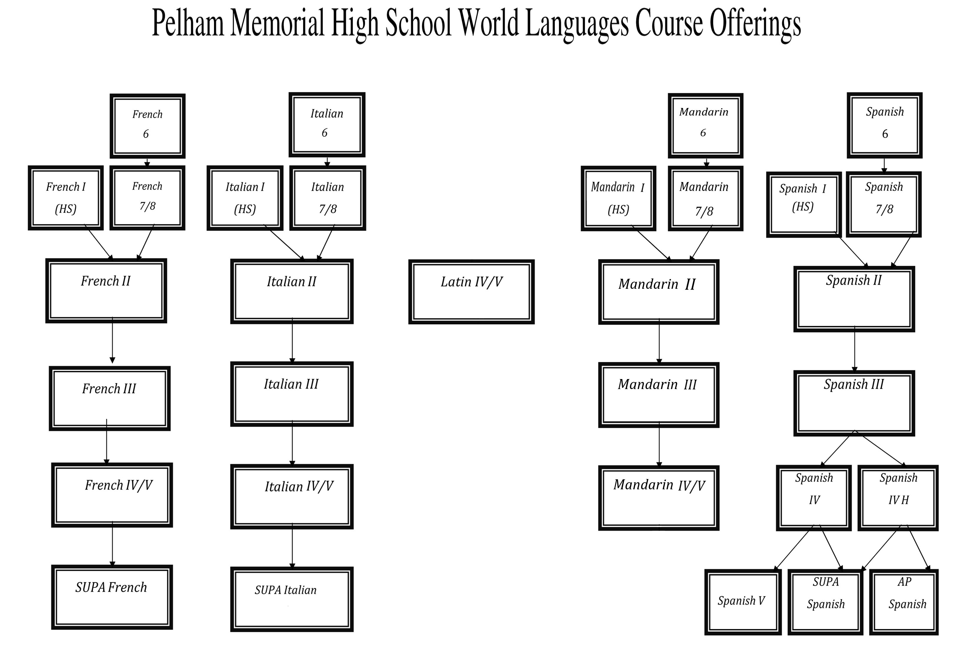
WORLD LANGUAGE DEPARTMENT

"He who is ignorant of foreign languages knows not his own" -Goethe

VISION STATEMENT

The World Language Department seeks to create an environment that enables students to communicate in the target language, to negotiate cultural differences, to develop understandings of cultural and linguistic heritages, and to become lifelong language learners and world citizens.

Our Program includes opportunities:

-to participate in National Language Contests
-to become members of the French, Italian, Latin and Spanish National Honor Societies during the fourth or fifth year of language study
-to participate in cultural field trips
-to help the transition to college by offering college and career readiness courses
MODERN FOREIGN LANGUAGES

Modern Languages prepare students for a life in contemporary society where communication is the key to success. They provide us with the linguistic skills necessary to meet the demands of business, professional and everyday life. Students will broaden their horizons as they learn about the people and traditions of a foreign culture. Students may choose French, Spanish, Italian or Mandarin. The department encourages you to pursue a second foreign language as an elective. The cost of Syracuse University courses is approximately $110/credit.

FRENCH 1 Prerequisite: None
ITALIAN 1
SPANISH 1
1 Credit each course

Level 1 is an introduction to the target language and culture. A communicative-based approach is used in teaching the basic skills of a foreign language: listening comprehension, speaking, reading and writing. The cultural aspects are introduced through readings and supplementary materials. The language laboratory is an integral part of the course work.

MANDARIN 1 Prerequisite: None
1 Credit

This course is open to students who are beginning their study of a world language, or wish to begin their study of an additional world language. The course is designed to provide an introduction to the sounds, writing system and basic grammatical structures of modern Mandarin. Students will learn about traditional and contemporary Chinese culture and will learn to use Mandarin as a communication tool.

FRENCH 2 Prerequisite: Level 1
ITALIAN 2 SPANISH 2
1 Credit each course

Level 2 is the second course of the high school sequence. Continued emphasis is placed on developing and refining the 4 skills (listening, speaking, reading and writing). More complex grammar is presented and students learn to function in simple conversational situations. Cultural aspects are broadened. The language laboratory is an integral part of the course work.

MANDARIN 2 Prerequisite: Level 1
1 Credit

This course is designed for students who have successfully completed Mandarin 1. Students will continue to expand their vocabulary and learn complex grammar. They will further develop the 4 skills (listening, speaking, reading and writing) and broaden their cultural perspectives. The language laboratory is an integral part of the course.

FRENCH 3 Prerequisite: Level 2
ITALIAN 3
SPANISH 3
1 Credit each course

In level 3 continued emphasis is placed on developing and refining the 4 skills (listening, speaking, reading, and writing). Oral competency in functional situations is stressed. Cultural knowledge and the language laboratory continue to be an integral part of the course work. At the end of the course students are required to take a state approved exam that offers credit equivalent to the New York State Comprehensive Examination (Regents).

MANDARIN CHINESE 3 Prerequisite: Level 2
1 Credit

In level 3 continued emphasis is placed on developing and refining the 4 skills (listening, speaking, reading, and writing). Oral competency in functional situations is stressed. Cultural knowledge and the language laboratory continue to be an integral part of the course work. Increased emphasis will be placed on the writing of Chinese characters to improve students’ ability to write in Chinese. At the end of the course students are required to take a state approved exam that offers credit equivalent to the New York State Comprehensive Examination (Regents).

MANDARIN CHINESE 4/5 Prerequisite: Level 3
1 Credit

The course combines two levels of students for advanced study in Mandarin. The syllabus alternates year to year. It focuses on the language and culture of Chinese through the study of history, art, literature, film, music and current events. Throughout the course students are evaluated on listening, reading, writing and speaking skills. The course includes study of vocabulary and grammar. Projects and presentations are assigned during the year. The language lab continues to be an integral part of the coursework.

FRENCH 4/5 Prerequisite: Level 3
1 Credit

The course combines two levels of students for advanced study in French. The syllabus alternates year to year.
It focuses on the language and culture of France and other francophone countries through the study
of history, art, literature, film, music and current events. Throughout the course students are evaluated on listening, reading, writing and speaking skills. The course includes study of vocabulary and grammar. Projects and presentations are assigned during the year. The language lab continues to be an integral part of the coursework.

INTERMEDIATE FRENCH, (Syracuse University FRE 201) Prerequisite Level IV
College credit: 4 credits Open to Seniors Only

This course allows students with skills at the Intermediate level to continue their learning of the language and to prepare them for continuing into advanced university courses. By the end of the course, students should be able to sustain understanding of main ideas and details over long stretches of continued discourse, whether written or oral. They should also be able to read a variety of texts with increased comprehension and to write well enough to meet practical needs. Course work will include the use of film and video to develop listening and note taking skills; role playing, interviews, and extended narrative accounts to develop speaking skills; and the composition of letters, journals, summaries and reports to develop writing skills. The class is conducted in French. This is a college course offered through Syracuse University. Students pay the discounted fee (approx. $460) to Syracuse University. Upon successful completion of the course, students are entitled to a SU transcript for the four credits earned. Criteria for admission includes an 85 average in level 4 and teacher/supervisor recommendation based upon the listening and speaking skills of the student.

ITALIAN 4/5 Prerequisite: Italian 3
1 Credit

The course combines two levels of students for advanced study in Italian. The syllabus alternates year to year.
It focuses on the language and culture of Italy through the study of history, art, literature, film, music and current events. Throughout the course students are evaluated on listening, reading, writing and speaking skills. The course includes study of vocabulary and grammar. Projects and presentations are assigned during the year. The language lab continues to be an integral part of the coursework.

INTERMEDIATE ITALIAN (Syracuse University ITA 201) Prerequisite Level IV
College credit: 4 credits Open to Seniors Only

This course is designed to further develop, strengthen, and refine students’ language skills. Conducted completely in Italian, the course will review Italian grammar, polish writing and speaking skills, and offer consistent exposure to Italian language and culture. Class work will include interactive oral activities, weekly
compositions, and reading and discussion of a variety of authentic texts that span literature, current events, and cultural life. In addition, students will watch films, documentaries, and Italian television programs as the basis for written assignments and discussion. The class is conducted in Italian. This is a college course offered through Syracuse University. Students pay the discounted fee (approx. $460) to Syracuse University. Upon successful completion of the course, students are entitled to a SU transcript for the four credits earned. Criteria for admission includes an 85 average in level 4 and teacher/supervisor recommendation based upon the listening and speaking skills of the student.

SPANISH 4 Prerequisite: Level 3
1 Credit

The course focuses on the language and the culture of Spanish speaking countries through the study of history, art, literature, film and music. Throughout the course students are evaluated on listening, reading, writing and speaking skills. The course includes some study of vocabulary and grammar; however, grammar is not the primary focus. Projects and presentations are also assigned during the year.

SPANISH 4 (H) Prerequisite: Level 3
1 Credit

This course is intended for qualified students who wish to take AP Spanish the following year and/or who wish to complete studies in secondary schools comparable in difficulty and content to a college course. Students should have attained an advanced proficiency in listening, reading, speaking and writing in order to enroll in this course. Emphasis is on refining listening, speaking, reading and writing. Class presentations, independent lab work, and independent reading assignments are an integral part of the course. The class is conducted in Spanish. Student must have comfort in hearing the language and using it for communication and written expression.

SPANISH 5 Prerequisite: Level 4
1 Credit

This course continues to refine speaking, listening, reading and writing skills. It focuses on the language and culture of the Spanish speaking world through the study of history, art, literature, film, music and current events. Various texts, teacher-prepared materials, and films are used. Group projects and presentations are assigned throughout the year. Language laboratory continues to be an integral part of the course work. The course is primarily conducted in Spanish.

SPANISH 5 AP Prerequisite: Level
1 Credit 4 Honors Spanish

This course is intended for qualified students who wish to complete studies in secondary school comparable in difficulty and content to a college course. Students should have attained an advanced proficiency in listening, speaking, reading and writing in order to enroll in this course. The course will prepare the students for the Advanced Placement examination in May. The student will be required to communicate entirely in Spanish. Emphasis is on refining the 4 skills (listening, speaking, reading, and writing). Students are expected to read and discuss whole literary works in Spanish. Language laboratory continues to be an integral part of the course work. Students are required to take the AP exam.

INTERMEDIATE SPANISH (Syracuse University SPA 201) Prerequisite Level IV
College credit: 4 credits Open to Seniors Only
Using film, TV/radio, and literary texts, this proficiency-based course reviews understanding of the formal structures of language, refines previously acquired linguistic skills, and builds awareness of Spanish culture. Students will use sources in a variety of media to develop oral, listening, writing, and reading skills. By the end of the course, students can be expected to communicate effectively in the language in order to give and get information; survive both predictable and complicated situations, narrate and describe in present, past, and future time; support opinions; and hypothesize. Classes are conducted in Spanish. This is a college course offered through Syracuse University. Students pay the discounted fee (approx. $460) to Syracuse University. Upon successful completion of the course, students are entitled to a SU transcript for the four credits earned. Criteria for admission includes an 85 average in level 4 and teacher/supervisor recommendation based upon the listening and speaking skills of the student.

THE CLASSICS

Latin is the foundation of the Romance languages and a powerful influence in English grammar and vocabulary. It is a primary source of Western literature. Latin focuses primarily on linguistic and literary analysis. It encourages precision with words and offers valuable lessons for close reading and written expression in English. Beyond language skills, Latin offers the best access to the culture of the ancient world, which forms the basis of much of our modern thinking. Latin is recommended for its intrinsic value and also to enhance the study of modern languages, English, and history.

IMPORTANT: Due to low enrollment the district will be phasing out Latin over the next two years.

LATIN 4/5 Prerequisite: Latin 3
1 Credit

This course combines two levels of students for advanced study in Latin. The syllabus alternates year to year. Curriculum “A” is dedicated to selections of Vergil’s Aeneid, as well as selections of the Greek poet Homer. Curriculum “B” is dedicated to selections from Caesar’s De Bello Gallico and the Letters of Pliny the Elder. Special emphasis is placed on accurate translation, historical context, critical interpretation, and metre. Literary devices and syntax will also be closely studied.

